NC Math 1B Name: ________________________

Unit 7B Lesson 3 Homework: Comparing Linear and Exponential Data

I. Determine whether each scatter plot would best be modeled by a linear function, exponential function, or neither.
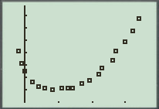
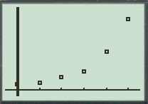
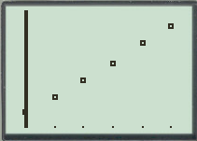
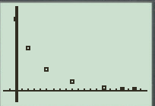
- 2. 3. 4.

II. State whether the following sets of variables would show a positive, negative, or no correlation.

- Weight of a car and its gas mileage

- An adult hand size and his or her salary

- Money earned by a hostess and the time spent working

- Time money sits in a savings account and the interest it earns

- Speed you drive and the length of time it takes to reach your destination

III. Multiple Choice

- The amount a window washer charges varies depending upon the number of hours worked and the type of windows. The table shows the amount charged for several jobs. Which graph represents the data?

Hours Worked | 1 | 3 | 5 | 6 | 3 | 1
Amount Charged | $20 | $50 | $70 | $80 | $60 | $30
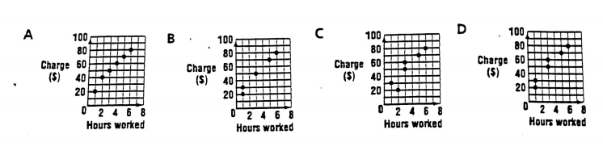

- Refer to question #1 above: which ordered pair represents the amount charged for a job that took 5 hours of work.

- (5, 70) B. (70, 5) C. (3, 50) D. (50, 3)

- Refer to question #1 above: Which equation best represents the data?

- $y=13x$ B. $x=11y+17$ C. $y=5x+35$ D. $y=10x+20$

- Refer to question #1 above: What is the most accurate interpretation of the slope of the line?
- For each increase of 1 hour of time, the cleaning charge increases by about $5.
- The window washer charges $20 for appearing at the job site.
- For each increase of 1 hour of time, the cleaning charge increase by about $0.
- For each hour of time, the cleaning charge is about $13.

- Refer to question #1 above: What would be the best prediction for the cost of an average job that requires 4 hours of work?

- $50 B. $100 C. $60 D. $80

