NC Math 1B Name: ________________________

Unit 7B Lesson 2 Homework: Correlation Coefficient

I. State whether the following sets of variables would show positive, negative, or no correlation.

- The weight of a car and its gas mileage
- A person’s height and their weight
- An adult hand size (measured in inches) and his or her starting salary
- Amount of money earned by a waiter and the amount of time they spend on the job
- Grades in school and the number of absences from school
- Temperature of a cup of coffee and the time it sits on the table
- A person’s height and the numerical date of their birthdate
- The amount of snow on the ground and the outside temperature
- The amount of time you exercise and the amount of calories you burn
- The amount of time a pot of water boils and the amount of water in the pot

II. The table below shows the average number of miles per gallon of gasoline of motor vehicles for each year given. Use the data to create and answer at least three questions about automobile fuel efficiency.

Year | 1982 | 1983 | 1984 | 1985 | 1986 | 1987 | 1988 | 1989 | 1990
MPG | 16.65 | 17.17 | 17.83 | 18.20 | 18.27 | 19.20 | 19.87 | 20.31 | 20.92

III. Match each r-value to its appropriate scatter plot.
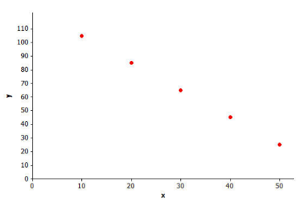
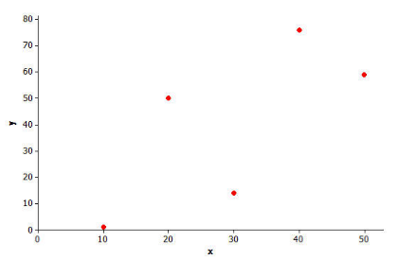
A. B.
__________1. $r=1$

__________ 2. $r=-0.63$

__________ 3. $r=0.72$

__________ 4. $r=-1$

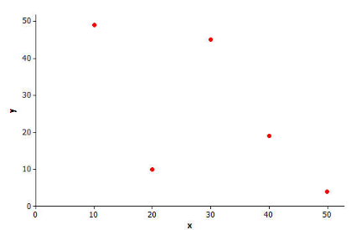
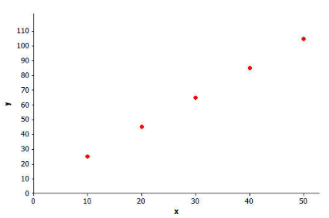
C. D.
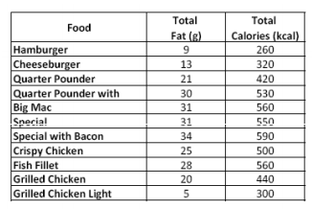
IV. The data in the table below shows the total fat (in grams) and the total calories in (kcal) for several menu choices at McDonald’s. Use the data to answer the related questions.

- Based on the data, does there appear to be a relationship between total fat and total calories? If so describe the type of correlation that exists and explain why.

- Does the scatter plot of the data below confirm or change your answer to question 1 above? Explain.

- Based on the scatter plot, do you think the data has a strong, weak, or no correlation? Explain your thinking.

- The data above can be modeled using the equation: $y=11.731x+193.852$

The correlation coefficient for the data above is: $r=.975$

- Based on your correlation coefficient, describe the strength of the relationship.

- McDonald’s added a new menu item called the Southern BBQ Pork Sandwich. The total fat in this sandwich is 8 grams. How many calories would you expect this sandwich to have? SHOW WORK!

- McDonald’s reworked their recipe for their Big Mac and was able to reduce the number of calories by 20% bringing it down to 448 calories. About how many grams of fat would the new Big Mac contain? SHOW WORK!

