NC Math 1B Name: ________________________

Unit 7 Lesson 4 Homework: Standard Deviation, Choosing the Best Measure, Comparing Box Plots

I. Standard Deviation

1. The selling prices of houses in a neighborhood in Cary have a mean of $259,000 and a standard deviation of $15,000.
Describe the standard deviation in context:

2. In the annual fishing competition, there were 10 competitors who caught fish. Each participant weighed their total catch and recorded their weights. There were 10 competitors. The weight of their fish were 23 pounds, 37 pounds, 82 pounds, 49 pounds, 56 pounds, 70 pounds, 63 pounds, 72 pounds, 63 pounds, and 45 pounds. Calculate the standard deviation of the data and interpret it using context.

- Calculate the Standard Deviation of the Data

MEAN ($\overline{x}$) = __________

Observations | Deviations from Mean ($x_{i}$ - $\overline{x}$) | Squared Deviations ($x_{i}$ - $\overline{x}$)²
23
37
82
49
56
70
63
72
63
45
 | SUM = | SUM =

Standard Deviation:

- Describe the standard deviation in context:

II. Short Answer

1. Which measure of spread goes with Mean as the measure of center?

2. Which measure of center goes with interquartile range as the measure of spread?

3. Which measure of center should be used if the data set contains an outlier?

4. Which measure of spread should be used if a data set contains an outlier?

5. Which measure of center should be used if the data set does not contain an outlier?

6. Which measure of spread should be used if the data set does not contain an outlier?

III. Comparing Box Plots

Delia wanted to find the best type of fertilizer for her tomato plants. She purchased three types of fertilizer and used each one on a set of seedlings. After 15 days, she measure the heights (in centimeters) of each set of seedlings. F The data she collected and plots of the data are shown below. Use this information to answer the following questions for each of the fertilizers.
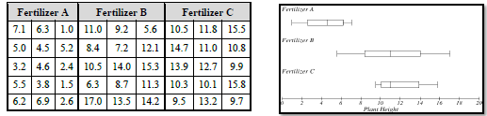

 | Fertilizer A | Fertilizer B | Fertilizer C
Mean
Median
Range
IQR
Shape
Best Measure of Center
Best Measure of Spread

Make a convincing argument for which fertilizer should be used (include numerical data as well as information about shape in your argument).

