NC Math 1B Name: ________________________

Unit 7 Lesson 2 Homework: Shape, Measures of Center, Box Plots

I. The heights of Cary High School’s basketball players are: 69 inches, 64 inches, 67 inches, 66 inches, 65 inches, 63 inches, and 67 inches. A student transfers to Cary High and joins the basketball team. Her height is 82 inches.

- What is the mean height of the team before the new player transfers in? What is the median height?

- What is the mean height after the new player transfers? What is the median height?

- What affect does her height have on the team’s height distribution and stats (center and spread)?

- How many players are taller than the new mean team height? How many players are taller than the new median team height?

II. Below is data of the amount of money spent by 25 shoppers at a grocery store.

$3 $6 $10 $11 $17 $18 $19 $20 $20 $23 $26 $28 $31 $33 $34

$37 $42 $45 $45 $50 $65 $72 $76 $97 $113

- Calculate the mean.

- Calculate the median.

- Calculate the lower and upper quartiles.

- Calculate the IQR.

- Interpret the IQR using context from the problem.

III. Answer each question based on the box and whisker plot below.
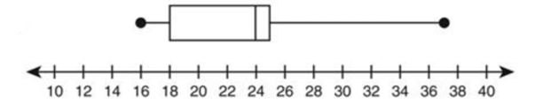

Median = ___________ Max = ___________ Min = ___________

Q₁ = __________ Q₃ = __________ IQR = __________
IV. For each graph below, determine whether the shape is symmetric, uniform, skewed left, or skewed right.

