YL Honors Math 2 Name: _____________________

Unit 6 Lesson 2 Homework: Reflections

I. Graph Each by

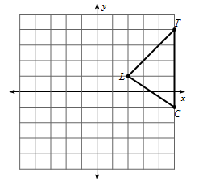
1. Reflecting the shape over the x – axis: 2. Reflecting the shape over the y - axis:

3. Reflecting the shape over the line $x = -1$ 4. Reflecting the shape over the line $y = -x$

II. Write the ordered pair to reflect each set of points – use your rules to help you!

5. $(-3, 7)$ and $(10, -2)$ over the y-axis 6. $(-6,5)$ and$(9, -1)$over the line $y = x$

7. $(0, -6)$ and $(-2, 5)$ over the line $y = -x$ 8. $(4, 4)$ and $(7, 2)$ over the x-axis

III. Write a function rule to represent the transformation that would map the given domain to the given range. Describe the transformation using mathematical vocabulary.

- Domain: $\{U\left(-4,-4\right),V\left(-3,1\right),W\left(0,-1\right)\}$ 10. Domain: $\left\{Q\left(0,0\right),R\left(3,4\right),S\left(3,0\right)\right\}$
Range: $\{U^{'}\left(4,-4\right),V^{'}\left(3,1\right),W^{'}\left(0,-1\right)\}$ Range: $\{Q^{'}\left(0,0\right),R^{'}\left(3,-4\right),S^{'}\left(3,0\right)\}$

IV. Quadrilateral $A'B'C'D'$ is a reflection of quadrilateral $ABCD$ across the given line.
- Draw line segments connecting $A$ to $A'$ and $C$ to $C'$

- Label the points of intersection with the line of reflection as E and F.

- Mark each statement as true or false.

  - $A$ and $A'$ are equidistant from the line of reflection.

  - $C$ and $C'$ are equidistant from the line of reflection.

  - This reflection is equivalent to a $f\left(x,y\right)=(x-2,y-4)$

  - The quadrilaterals are reflected over the line $y=-x$

  - $\overline{AA^{'}}∥\overline{CC^{'}}$

V. Review
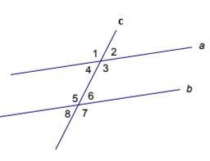
- Name the type of each given angle pair if $a∥b$ and is cut by transversal c.

  - $∠3 and ∠5$
  - $∠4 and ∠8$
  - $∠8 and ∠6$
  - $∠4 and ∠3$

- Using the figure in #14 above, find the measure of the remaining angles if you know $m∠5=132°$.

