NC Math IB Unit 5 Review - Exponential Functions Name: ___________________

1. The North Carolina Zoo decided to run a TV ad to showcase their new Red Panda exhibit. Before they ran the ad they sold 136 tickets. They expect for ticket sales to double each day the ad runs.

  - Complete the table to show how many tickets the zoo will sell each day the ad runs.

Number of Days | 0 | 1 | 2 | 3 | 4 | 5
Number of Tickets Sold | 136

  - Write a NEXT-NOW statement to predict the number of ticket sales.

  - Write an explicit equation in function notation to predict the number of ticket sales.

  - Use one of your equations to predict how many tickets will be sold in 2 weeks?

  - When will there be exactly 15,000 tickets sold?

  - Assume a different zoo starts out selling 125 tickets? Complete the following.

Number of Days | 0 | 1 | 2 | 3 | 4 | 5
Number of Tickets Sold

NEXT-NOW rule: Explicit Equation:

How many in 2 weeks: When will exactly 15,000 tickets be sold:

2. Athletes can be disqualified from competitions for using anabolic steroids. These drugs are dangerous and leave the body slowly. Assume an athlete injects 100 mg of a steroid and 10% of the drug leaves the body each day.

a. Write two rules that describe the amount of steroid in the blood.

NEXT-NOW rule: Explicit Equation:

c. Use one of the rules in part a to estimate the amount of steroid left in the body after 0.5 days and 2 weeks.

d. Exactly how long will it take the steroid to be reduced to only 45 mg of the steroid left in the body?

3. In 2000, the number of people worldwide living with HIV/AIDS was estimated at approximately 36 million. That number was growing at an annual rate of about 15%.

a. Make a table showing the projected number of people around the world living with HIV/AIDS in each of the ten years after 2000, assuming the growth rate remains 15% per year.

Years after 2000 | 0 | 1 | 2 | 3 | 4 | 5 | 6 | 7 | 8 | 9 | 10
AIDS Cases  (in millions) | 36 | 41.4 | 47.61

b. Write two different kinds of rules that could be used to estimate the number of people living with HIV/AIDS at any time in the future.

NEXT – NOW Rule: _______________________________________

Explicit Equation: __________________________________________

c. Use the rules from part b to estimate the number of people living with HIV/AIDS in 2015.

d. What factors might make the estimate of part c an inaccurate forecast?

4. The tables and rules below model four exponential growth and decay situations. For each table there is a matching rule. Use what you know about the patterns of exponential relations to match each graph with its corresponding table and rule. In each case, explain the clues that can be used to match the items without any use of a graphing calculator or computer.
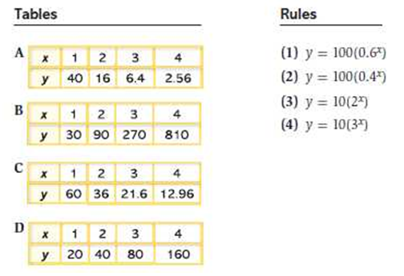
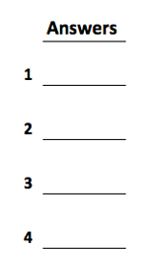

5. Exponential functions can be expressed by a rule relating x and y values and by a rule relating NEXT and NOW values.

a. Write a general rule relating NEXT and NOW for an exponential function.

b. Write a general rule for an exponential function ____________________

c. Write a general rule for percent exponential growth ___________________

d. Write a general rule for percent exponential decay ____________________

e. Write a general rule for compound interest __________________________

f. Explain what each variable represents for these rules?

g. How do you decide whether a given exponential function rule will describe growth or decay? Explain how you know.

Exponential Problems: Write and solve an equation for each.

6. One hundred bacteria triple every 6 hours. How many bacteria will there be after 8 hours? After half a day?

7. Christie put $1000 in a savings account which earns 7.5% interest compounded annually. How much money will she have in the account after 16 years?

8. A town with a population of 75,000 is increasing at a rate of 2% every two years. What will the population be in 10 years?

9. A copy machine under normal use depreciates at a rate of 18% per year. If the machine is purchased for $3600, what is the value after 5 years?

10. Find the final account balance if $3000 is invested at an interest rate of 6.75% compounded quarterly for 15 years.

11. The half-life of chromium-51 is 28 days. If the sample contained 510 grams, how much chromium would remain after 168 days?

Complete the table.
Equation | Growth or Decay? | Initial Amount | Growth or Decay Factor | % Percent of growth or decay
12. y = 7(0.39) ^{x}
13. y = (1.48) ^{x}
14. y = 4(1.723) ^{x}
15. y = 2(1 + 0.035)^{x}
16. y = 14(0.6) ^{x}
17. y = 5( 1 – 0.22) ^{x}

