NCM1B Name: _______________________

Unit 5 Lesson 4 Homework: Percent Decay

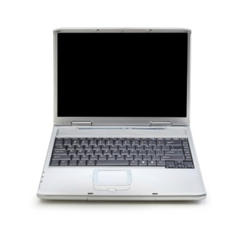
Use equations, graph, or tables to find the solutions to the problems below.

1. A computer valued at $6500 depreciates at the rate of 14.3% per year.
a) What is the initial value of the computer?
b) What is the percentage rate of depreciation?
c) Write a function that models the value of the computer.

d) Find the value of the computer after three years.

2. A new truck that sells for $29,000 depreciates 12% each year. Write a function that models the value of the truck. Find the value of the truck after 7 years.

3. A new car that sells for $18,000 depreciates 25% each year. Write a function that models the value of the car. Find the value of the car after 4 years.

4. Assume that your kidneys can filter out 10% of a medication in your blood every 6 hours. You take one 200-milligram dose of the medicine. How many milligrams of the medicine are in your blood after 2 days?

Complete the Table:

Exponential Decay Equation | Initial Amount | Decay Factor | % Percent of decay
$${y=27(1-.85)}^{x}$$

$$y=32{(.83)}^{x}$$

$$y=17(1-.03)^{x}$$

