NC Math 1B Name: ________________________

**Unit 5 Lesson 1 Homework: Recursive Growth and Decay**

If you don’t brush your teeth regularly, it won’t take long for large colonies of bacteria to grow in your mouth. Suppose a single bacterium lands on your tooth and starts multiplying by a factor of 4 every hour.

**Complete the table below to model the bacteria growth over several hours.**

|  |  |  |  |  |  |
| --- | --- | --- | --- | --- | --- |
| Hours | 0 | 1 | 2 | 3 | 4 |
| # of Bacteria | 1 | 4 | 16 |  |  |

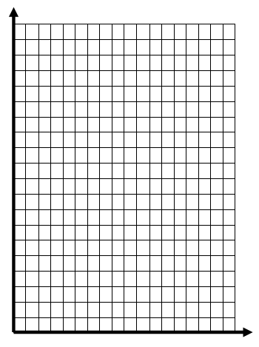



|  |  |  |  |  |  |  |  |  |  |  |  |  |
| --- | --- | --- | --- | --- | --- | --- | --- | --- | --- | --- | --- | --- |
|  |  |  |  |  |  |  |  |  |  |  |  |  |

1. Graph the data in the table. Label your graph and axes.

Is this graph quadratic, linear, or exponential? _____________

2. What is the initial value? ___________

3. What is the growth factor? __________

4. Write the *NEXT-NOW* rule to show the pattern of growth.

*NEXT* = _________________ start at: _________

5. Use the rule to calculate the number of bacteria after 7 hours.

6. After how many hours will there be at least 1,000,000 bacteria in the colony?

7. Suppose that instead of 1 bacterium, 50 bacteria land in your mouth. Write a *NEXT-NOW* rule to represent this change. ***(Don’t forget … start at:*** *_______****)***

8. Using the new *NEXT-NOW* rule from # 7, determine the number of bacteria in the colony after 4 hours.

Suppose the average Twizzler is 20 centimeters long; and thateach bite that you take cuts the candy exactly in half.



**Fill out the table below and use it to answer each of the following questions. (Round to the hundredths)**

|  |  |  |  |  |  |  |
| --- | --- | --- | --- | --- | --- | --- |
| Number of Bites | 0 | 1 | 2 | 3 | 4 | 5 |
| Remaining Twizzler | 20 |  |  |  |  |  |



9. Graph the data in the table. Label your graph and axes.

Is this graph quadratic, linear, or exponential? _____________

10. What is the initial value? ___________

11. What is the decay factor? __________

12. Write the *NEXT-NOW* rule to show the pattern of growth.

(*Don’t forget a START value!*)

13. Now calculate how much Twizzler would remain after 10 bites.