NCM1B Unit 4 Quadratics Part 1 Review Name _______________

I. Short Answer

1. The graph of a quadratic equation is called a ___________________

2. Quadratic equations have a degree = ______ which tells us the equation has _____ ______________

3. List the 4 steps to solving a quadratic equation by factoring.
- a. __________________________________________
- b. __________________________________________
- c. __________________________________________
- d. __________________________________________

4. GCF, Box, Bust up the B, and DOTS all are methods we use to _____________________.

5. ___________ ___________ ______________ means to set each factor with a variable equal to zero when solving a quadratic equation by factoring.

6. Solutions to an equation are also called _________________ and ____________________.

7. The ________________when you solve an equation are the x-intercepts when you graph the equation.

II. For each graphed parabola, state the following:
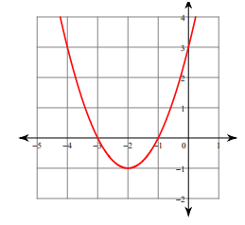
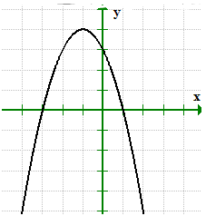
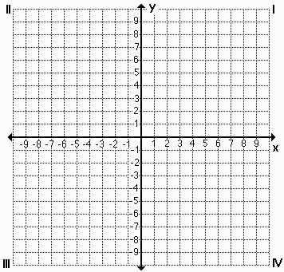
8. 9. 10.

x-intercept(s): ________________ x-intercept(s): ________________ x-intercept(s): ________________

III. Solve each quadratic equation by factoring.

11. n² – 8n = 0 12. n² – 3 = – 2n 13. 4m² + 8m – 12 = 0

14. a² = 11a – 30 15. (4x + 3) (x – 6) = 0 16. 7n² = 28

17. (t + 2) (t – 2) = – 3 18. x² + 13x –14 = 0 19. c² – 52 = 17c + 8

20. 3x² = –15x 21. x² – 36 = 0 22. 2x² – 2x – 24 = 0

23. $-13x+5x^{2}=6$ 24. $-4x^{2}=-4x-3$ 25. $18x^{2}-28x-25=5x-4$

IV. Solve by Square Root

26. $x^{2}=36$ 27. $x^{2}+9=18$ 28. ${(x+4)}^{2}=100$

29. $4k^{2}+18=19$ 30. $x^{2}-16=0$ 31. $6x^{2}=24$

32. $x^{2}=81$ 33. ${(x-4)}^{2}=144$ 34. $-8x^{2}=-72$

35. ${(3x+4)}^{2}=225$ 36. ${5x}^{2}=125$ 37. $x^{2}+2=3$

V. Applications

38. A relief package is released from a helicopter at 1600 feet. The height of the package can be modeled by the equation $h\left(t\right)=-16t^{2}+1600$, where h is the height of the package in feet and t is the time in seconds. How long will it take the package to hit the ground?

39. The height of a rock thrown off a cliff can be modeled by the equation $h\left(t\right)=-16t^{2}-8t+120$, where h is the height in feet and t is the time in seconds. How long will it take the rock to reach the ground?

40. One positive number is 4 less than twice another number. The product of the two numbers is 126. Find the two numbers.

41. Two negative consecutive odd integers have a product of 255. Find the integers.

42. The length of a rectangle is three more than four times the width. The area of the rectangles is 10 square meters. Find the dimensions of the rectangle.

43. The height of a triangle is two more than four times the base. The area of the triangle is 15 square feet. Find the base and the height of the triangle.

