NC Math IB – Unit 4 Part 2 Review Name: _______________________

**(NO Graphing Calculator Needed)**

**I. Changing the Viewing Window**

Describe what could be done on the graphing calculator to see the entire parabola graphed.

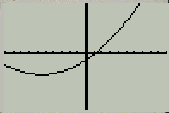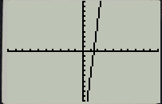

1. 2.

**II. State the key features for the given parabola.**

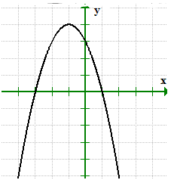

Vertex: ______________ Axis of Symmetry: _____________

Zeros: _____________ X-Intercepts: _______ ________

Y-Intercept: __________ Maximum or Minimum (Circle)

Domain: _____________ Range: ____________________

Increasing: ___________ Decreasing: ___________

1**.**

**III. Applications**

1. A t-shirt gun at a football game shoots a t-shirt in the air with an initial velocity of 40 ft/ s. The table below shows the various **heights** (in feet) recorded at certain **time** intervals (in seconds).



**Use the table to answer the following:**

|  |  |
| --- | --- |
| **t** | **h** |
| 0 | 0 |
| 1 | 36 |
| 3 | 84 |
| 4 | 96 |
| 5 | 100 |
| 6 | 96 |
| 7 | 84 |
| 9 | 36 |
| 10 | 0 |
|  |  |
|  |  |

a. When is the t-shirt is at ground level? ___________ ____________

b. The t-shirt is 96 feet in the air at what times? ____________ _____________

c. What is the maximum height reached by the t-shirt? _____________

d. How long does it take for the t-shirt to reach the maximum height? ________

e. How long was the t-shirt airborne? _____________

f. What is the t-shirts’s height at 3 seconds? _______ 1 second? _______

g. Describe the vertex, what does it mean? ______________________________

______________________________________________________________

|  |  |
| --- | --- |
| **t** | **h** |
| 0 | 5 |
| 1 | 8 |
| 2 | 9 |
| 3 | 8 |
| 4 | 5 |
| 5 | 0 |
|  |  |
|  |  |

2. Ms. Bass and Ms. Putman are playing fetch with their dogs at the dog park. Ms. Bass is standing on a large rock when she throws her ball to Copper. The path of the ball in terms of height (in feet) and time (in seconds) is recorded into the table below. The path of the ball Ms. Putman throws to Lenny can be modeled using the equation: $h\left(t\right)=-6t^{2}+12t$



1. Whose ball was airborne the longest? (Ms. Bass’ or Ms. Putman’s) ______________
2. From how much higher up did Ms. Bass throw her ball than Ms. Putman? ________

3. Patrick and Suzie are playing darts. They are not very good because none of the darts are making it to the target, they are landing on the ground. The path of Patrick’s dart is modeled by the table and Suzie’s dart is modeled by the graph.



1. How much longer was Patrick’s dart in the air compared to Suzie’s? ____________
2. Whose dart went higher? _____________



Patrick’s Dart

Suzie’s Dart

By how much? ______________

|  |  |
| --- | --- |
| **t** | **h** |
| 0 | 6 |
| 2 | 8 |
| 4 | 6 |
| 6 | 0 |
|  |  |
|  |  |

1. How much taller is Patrick than Suzie? ____________