NC Math 1B Name: ________________________

Unit 4 Lesson 4 Homework: Comparing Quadratics

Answer the following questions using the given equation, table, and/or graph.

Sally and Sam are testing out their new potato shooters from their tree houses which are at different heights. The chart to the right shows the time, t, in seconds and height, h, in meters of the potato pieces shot from Sam’s shooter. The time, t, and height, h(t), of Sally’s potato shooter can be represented by the following equation: $h(t)=-t^{2}+4t+5$.
Sam’s Shooter
t | h
0 | 7
0.5 | 9
1 | 10
1.5 | 10
2 | 9
2.5 | 7
3 | 4
3.5 | 0

1. Whose potato pieces hit the ground first? Sally or Sam’s?

2. What is the difference in seconds between when Sally and Sam’s potatoes hit the ground?

.
Two small children, Michael and Victoria, are trying to see who can throw a rock higher in the air. The graph on the right shows the path of Michael’s rock. The table on the right shows the time, t, in seconds and height, h, in feet of Victoria’s rock.
Victoria’s Rock
t | h
0 | 4
0.5 | 7
1 | 9
1.5 | 7
2 | 4
2.5 | 0
Michael’s Rock
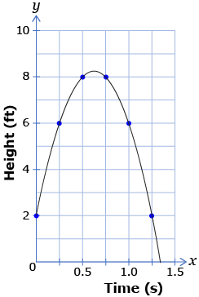
3. What was the initial height of Michael’s rock?
….Victoria’s rock?

4. Whose rock went the highest? Michael’s or Victoria’s?

5. Did their rock actually travel farther in the air? Why/why not?

