NC Math 1B Name: ________________________

Unit 4 Lesson 2 Homework: Solving Quadratic Equations using the Calculator

I. Complete the following:
1. Where on the graphing calculator do you go to accurately find the solutions to a quadratic equation?
________ _____________ __________

For each parabola label the left bound and right bound locations for each indicated x – intercept.

2. 3.
__________ bound
x - int
__________ bound
__________ bound
x - int

4. 5.
__________ bound
__________ bound
x - int
__________ bound
x - int

II. State the key features listed for the quadratic equation graphed below.
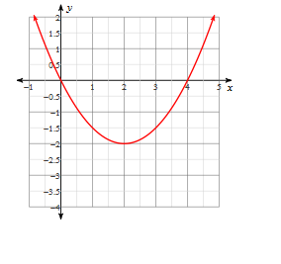
Vertex: ___________________
Axis of Symmetry: ________________
Y- Intercept: _____________
Zeros: _____________
X-Intercepts: __________ ___________
Maximum or Minimum (Circle)
Domain: ___________________
Range: ____________________
Increasing: _________________
Decreasing: ________________

6.

