NC Math 1B Unit 4 Part 2 Name: ________________________

Homework Lesson 2.5: More Graphing Quadratics on the Calculator

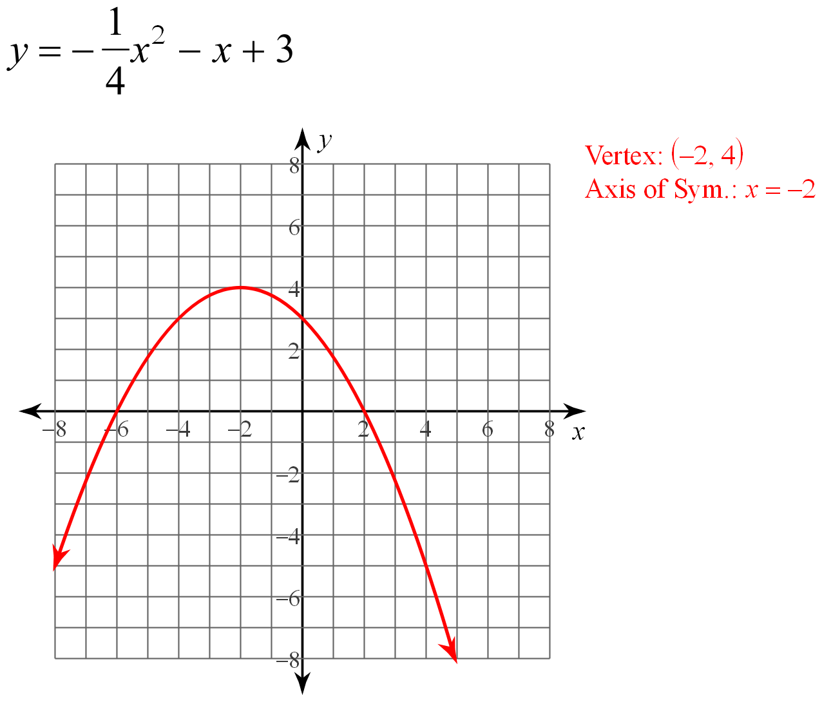
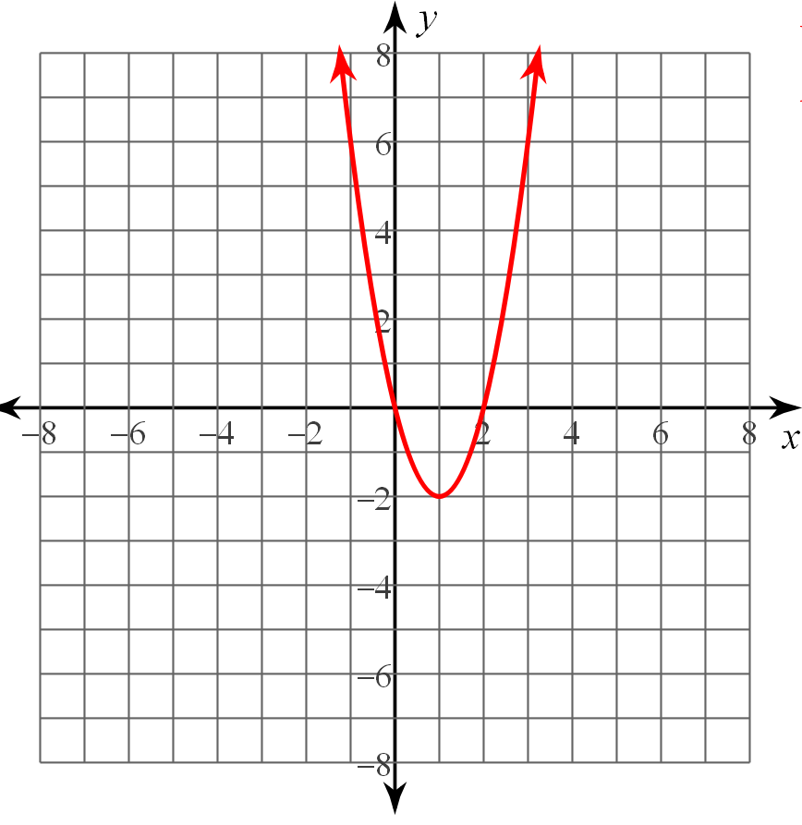
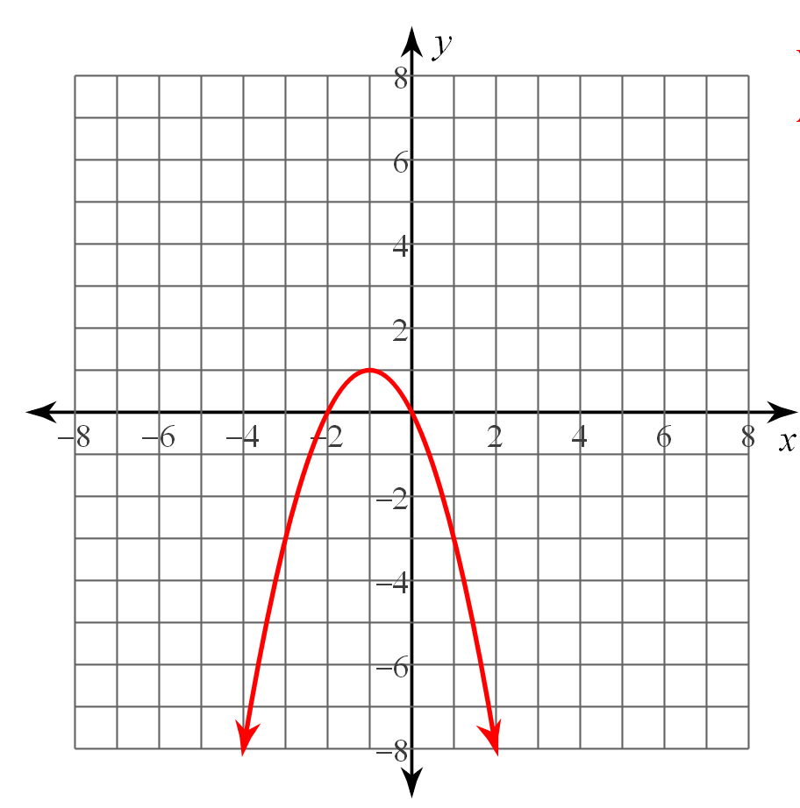
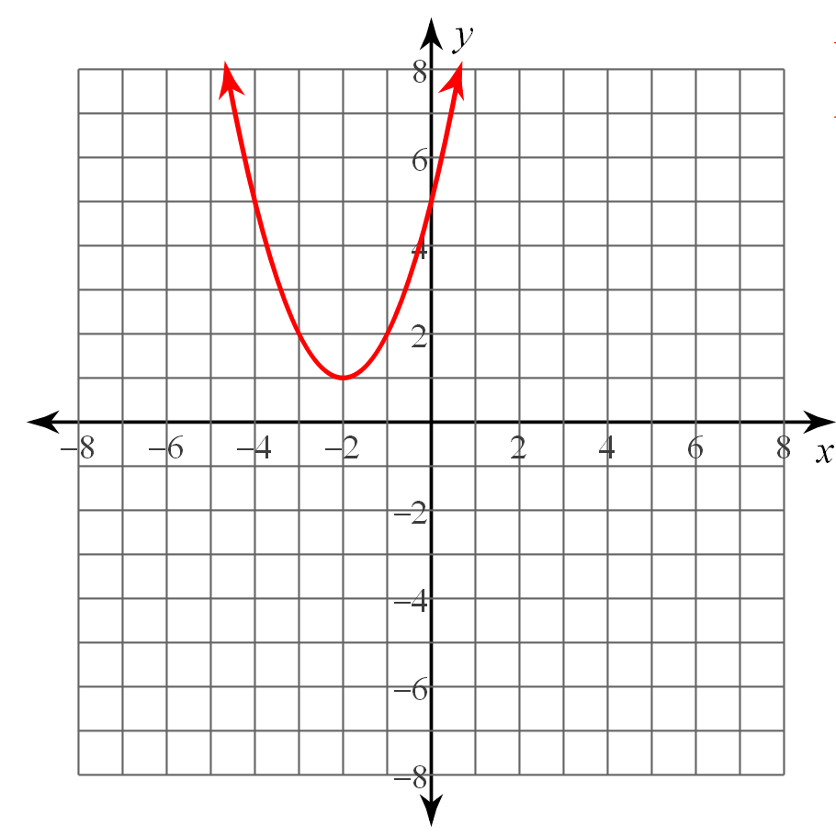
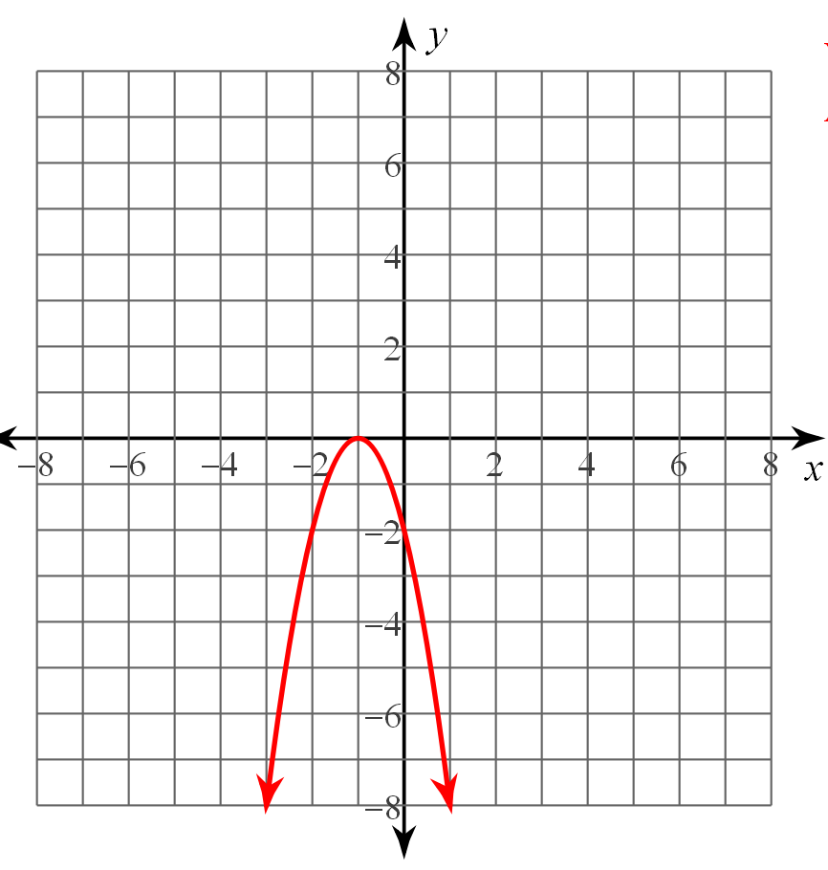
Use the given graphs to answer the following questions. Each question has at least one answer. Some questions have more than one graph that fit the description.
Graph A
Graph E
Graph D
Graph C
Graph A
Graph B

Which graphs have (a/an):

1. Axis of symmetry that is x = –1

2. Range of y ≥ 1

3. Maximum

4. Two solutions

5. Increase when x <–2

Mark the following places on Graph A:

6. Place a point ( ) for each x-intercept.

7. Put an “ X ” for left bounds (there should be 2)

8. Put a “ ” for the right bounds (there should be 2)

9. Draw and state the axis of symmetry

10. State the range

Describe what could be done on the graphing calculator to see the entire parabola graphed. What is missing? What would you press on the calculator to view what is missing?

11) 12)

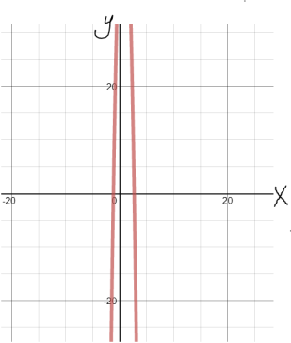
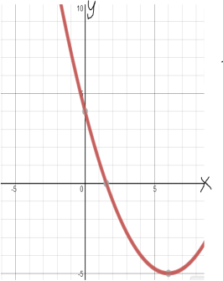

Given the vertex and x-intercepts or solutions for each equation, sketch and label the parabola and list the following key features:

13) y = x² – x – 6 14) y = –3x² – 5x + 10

Vertex: (0.5, –6.25) Vertex: (–0.83, 12.08)
Solutions: {–2, 3} x – intercepts: (–2.84, 0) and (1.17, 0)
Axis of Symmetry: _______
Zeros: _______________
Maximum or Minimum (Circle)
Domain: ___________________
Range: ____________________
Increasing: _________________
Decreasing: ________________

Axis of Symmetry: _______
X-Intercepts: _______________
Maximum or Minimum (Circle)
Domain: ___________________
Range: ____________________
Increasing: _________________
Decreasing: ________________

