NC Math 1B Unit 4 Part I Name: ________________________

Homework Lesson 1: Key Features of a Parabola

I. Identify the key features below each graph.
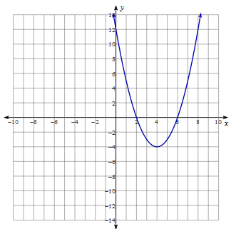
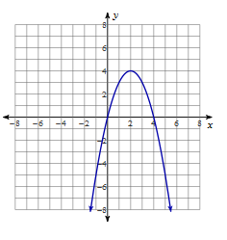
1. 2.

Axis of Symmetry: _____________
Vertex: __
Y- Intercept: __
Zeros: __
X- Intercepts: __
Maximum or Minimum (Circle)

Axis of Symmetry: _____________
Vertex: __
Y- Intercept: __
Zeros: __
X- Intercepts: __
Maximum or Minimum (Circle)

II. Solve by the indicated method

3. Factoring: $6x^{2}+5=-17x$ 4. Square Root: ${2x}^{2}-3=15$

5. Square Root: ${(2x-1)}^{2}=25$ 6. Factoring: $8x^{2}+48x=0$

III. Review

7. $(x-1)(2x+7)$ 8. ${(2x^{5}y^{2})}^{3}$ 9. $\left(x^{2}+3x-5\right)-({3x}^{2}+7-2)$ 10. $\frac{12x^{2}y^{5}}{3x^{-3}y^{8}}$

