NC Math 1B Name: ________________________

Unit 4 Part II Lesson 1.75 Homework: More Key Features

I. Identify the Key Features for each graph
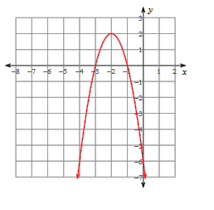
1. vertex: axis of sym:

solution(s): y-intercept:

x-intercept(s):

domain: increase:

range: decrease:

Maximum or Minimum (circle)

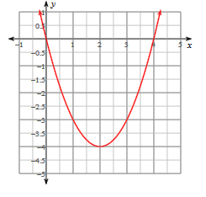
2. vertex: axis of sym:

solution(s): y-intercept:

x-intercept(s):

domain: increase:

range: decrease:

Maximum or Minimum (circle)

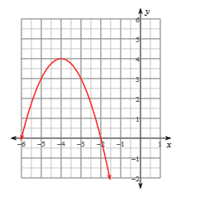
3. vertex: axis of sym:

solution(s): y-intercept:

x-intercept(s):

domain: increase:

range: decrease:

Maximum or Minimum (circle)

II. Solve by the indicated method

1. Factoring: $3x^{2}+24x+45=0$ 2. Square Root: $(3x-5)^{2}=4$

