NC Math 1B Name: ________________________

Unit 4 Part II Lesson 1.5 Homework: More Key Features of a Parabola
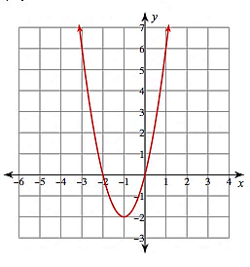
solution(s): vertex:

x-intercept(s): domain:

range:

y-intercept: increase:

axis of sym: decrease:

Maximum or Minimum (circle)
solution(s): vertex:

x-intercept(s): domain:

range:

y-intercept: increase:

axis of sym: decrease:

Maximum or Minimum (circle)

solution(s): vertex:

x-intercept(s): domain:

range:

y-intercept: increase:

axis of sym: decrease:

Maximum or Minimum (circle)

1.

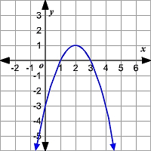
2.

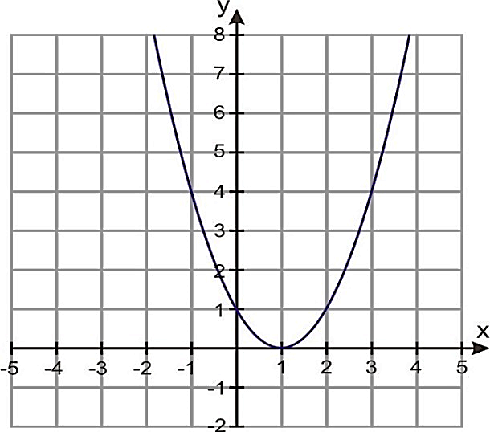
3.

SOLVE BY FACTORING or BY SQUARE ROOT PROPERTY

4. 6x² = – 21x 5. (3x – 1)² = 49 6. 16x – 12 = – 3x² + 9x + 8 7. 2x² – 76 = 52

