Unit 3 Review – Features of Functions

I. Determine whether each is a function or not. Simply write “yes” or “no”

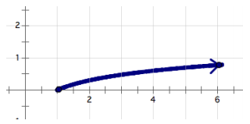
1. $\left\{(-7, 2\right), \left(3, 5\right), \left(8, 4\right), \left(-6, 5\right), (-2, 3)\}$ 2.

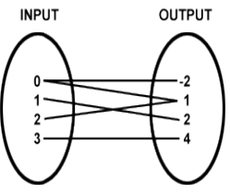
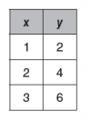
3. 4.

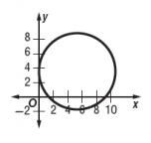
5. 6. $\left\{(1, -3\right), \left(3, 5\right), \left(1, 4\right), \left(-6, 5\right), (-2, 3)\}$

II. Use the graph below to identify the key features for the function.
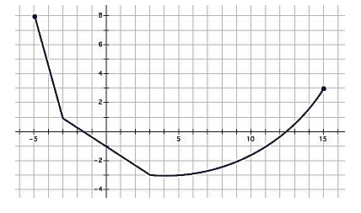
Domain: ______________________
Range: __________________
Increasing Interval: ___________________
Decreasing Interval: ____________________
Constant Interval: ___________________
x-intercept: __________ and __________
y-intercept: __________
Minimum: __________

III. Use the graph of $f(x)$ below to find the indicated values.

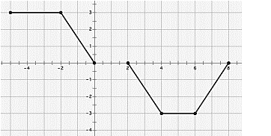
$f\left(-2\right)= __________$ $f\left(-1\right)= __________$
$f\left(0\right)= _________$ $f\left(6\right)= __________$
$$f\left(x\right)=1 if x= __________$$
$f\left(x\right)=0 if x= _________, __________, __________$

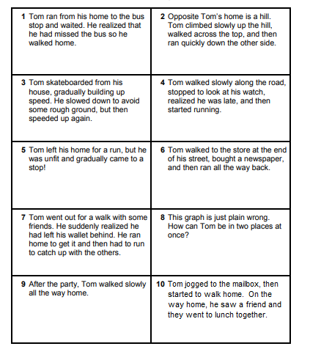
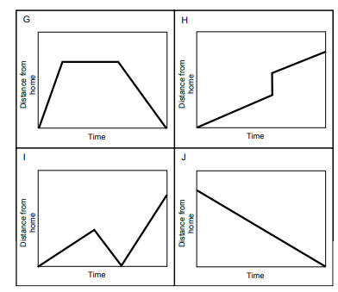
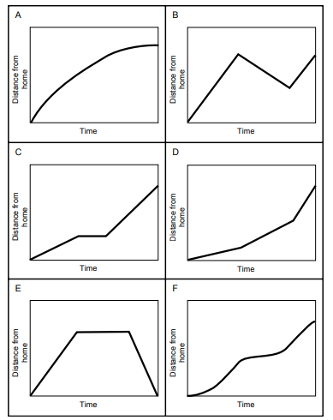
IV. Match the story to the graph by placing the story number in the blank beside each graph. The units for each graph are a measurement of time (x) and a measurement of distance from home (y)

