**Unit 2 Review – Linear vs. Exponential Functions**

**Linear Exponential Percent**

$y=mx+b$ $y=a{\left(b\right)}^{x}$ Percent to decimal DIVIDE by 100

$y=m\left(x-x_{1}\right)+y_{1}$ $y=a{\left(b\right)}^{\frac{x}{n}}$

$y=a{\left(1+b\right)}^{x}$ Decimal to percent MULTIPLY by 100

$y=a{\left(1-b\right)}^{x}$

$y=a{\left(1+\frac{b}{n}\right)}^{x∙n}$

**I. Linear Functions**

**Directions**: For each pair of points, plot the ordered pairs and draw a straight line through them. Then calculate the slope of the line.

1. and 2. and

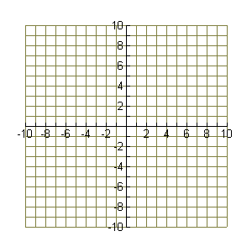

**Write the equation of the line that passes through the points.**

3. and 4. and $(– 1, 7)$

**Write a linear equation for each:**

5. and contains the point $(5, -9)$ 6. Slope = $6$ and contains the point

7. When Anna bought shares of stock in Target, she paid $37.50 per share. The value of a share increased linearly. After six months, each share was worth $45.00. Write a linear equation to model the stock’s value over time.

8. A video game rents for $3.99 per day. If a game is returned after the due date, a late fee of $2.50 is assessed. Write an equation to model the cost of renting the video game.

**II. Exponential Functions**

9.  Multiple Choice: What is a, the starting value, for the function: $f(x) = 300{\left(1.16\right)}^{x}$?

A. 300 B. 1.16 C. 0.16 D. x

10.  Multiples Choice: What does the b in $y=a{\left(1+b\right)}^{x}$ represent?

A. Time B. Growth Rate C. Slope D. Initial Amount

11. The number of mosquitoes at the beginning of the summer was 4,000. The population of mosquitoes is expected to grow at a rate of 25% per month. How many mosquitoes will there be after 4 months?

12.  Daniel’s Print Shop purchased a new printer for $35,000. Each year it **depreciates** at a rate of 5% per year. How much will the printer be worth in 8 years?

15.  The population of turtles is doubling every 3 months.  If there are 400 turtles now, how many will there be in 2 years?

13.  The population of the resort town of Java Hot Springs in 2003 was estimated to be 35,000 people with an annual rate of increase of about 2.44%. Write the equation that models the number of people in Java Hot Springs.

14.  Jimmy Page puts $300 into a savings account that promises 1% interest **compounded quarterly**. How much money will be in the account after 30 years?

15. A cut on your finger has 18 not-so-good bacteria in it. After 2 hours there are 288 bacteria. If the bacteria grew hourly what is the common ratio?