NCM1B Unit 2 Name: ___________________________

Date:

**Homework Lesson 5: Polynomial Applications (Triangles and Trapezoids)**

***Find the Area***

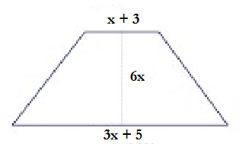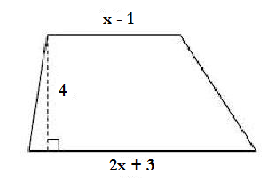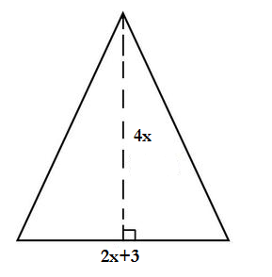

1. 2. 3.

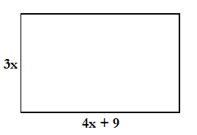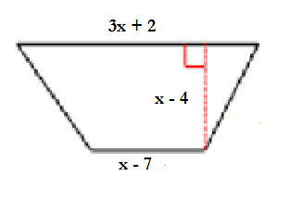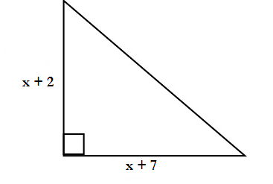

4. 5. 6.

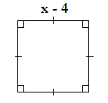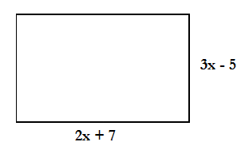

7. 8.

***Find the Perimeter***

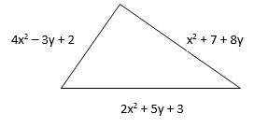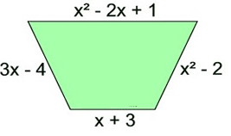

9. 10.