NCM1B Unit 2 Name: ___________________________
Date:

Homework Lesson 5.5: Find the Missing Polynomial and More Polynomial Applications

Assume that figures that appear to be rectangular are rectangles. Slash marks on the side of a polygon indicate corresponding sides are congruent (the same size).

1. Find the Perimeter: 2. Find the Perimeter:
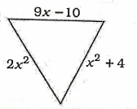
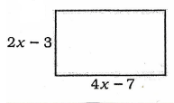

3. Find the missing side length. 4. Find the Area:
The perimeter is $3x^{2}-2x-5$.
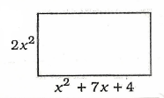
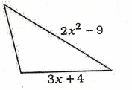

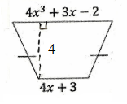
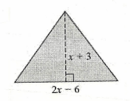
5. Find the Area: 6. Find the Area:

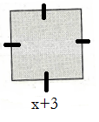
7. Find the Area: 8. Find the area of the rectangle whose
dimensions are $2x-3$ and $2x+1$.

9. A rectangular garden as a length of $x+8$ units and a width of $x-4$ units. If you increase the length and width of the rectangle by 4 units, what is the NEW area of the rectangle?

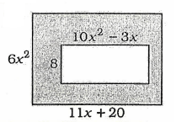
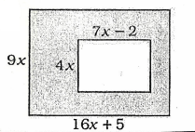
10. Find the Area of the Shaded Region: 11. Find the Area of the Shaded Region:

