NC Math 1B Unit 2 Name: ________________________
Date:

Homework Lesson 2.5: Adding or Subtracting Polynomials

1. Identify, explain, and correct the mistake in the subtraction problem below.

$$\left(2y^{2}-2y+7\right)-(6y^{2}-3y+2)$$
$$2y^{2}-2y+7-6y^{2}-3y+2$$
$$-4y^{2}-5y+9$$

Simplify:

1. $\left(3x^{2}+2x+6\right)+(5x^{2}+x)$ 2. $\left(2y^{5}+3y^{4}+4y^{3}+5y^{2}\right)-(4y^{2}+7y+6)$

3. $\left(-6k^{4}+19k+19\right)-(16k-10k^{2}-15)$ 4. $\left(10x+12\right)+(6x-20)$

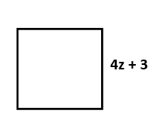
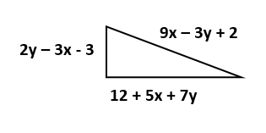
5. Find the perimeter 6. Find the perimeter

Review:

- Classify each polynomial as a monomial, binomial, or trinomial and explain your choice.
Polynomial | Monomial | Binomial | Trinomial | Why?
2x²
4r⁶ – 3r² – r
1
-9n + 10
x
-1

2. Find the degree of each polynomial 3. Write in descending order
a. $8a^{2}+13b^{3}$ a. $2+3x+4x^{2}+3x^{3}$
b. $928$ b. $-3x+17x^{4}+29x^{2}$

