NC Math I Fall 2016 Math 1A EOC Review
Unit 1- Solving Equations & Inequalities
Solve each equation. SHOW YOUR WORK!
1. $9+t=35$ 2. $\frac{z}{4}=\frac{1}{2}$ 3. $-2q-5=-11$ 4. $15=-t+3$

5. $-\frac{2}{5}x+4=8$ 6. $2\left(t+5\right)=9$ 7. $x-\left(4-x\right)=0$

Solve each, then graph the solution.
8. $\frac{c}{5}-4=-3$ 9. $7s-\left(3s+1\right)=4(3+s)$ 10. $3\left(2t-6\right)=2(3t-9)$

11. $h+3>2$ 12. $3m>5m+12$ 13. $6\left(c-1\right)≤-18$

Solve each for the indicated variable.
14. $A=\frac{1}{2}bh$ for b 15. $y=mx+b$ for b 16. $C=πd$ for d

17. The width of a rectangle is 6 cm less than the length. The perimeter is 72 cm. Write and solve an equation to find the width and the length of the rectangle.

18. The sum of three even integers is -198. Find the three integers.

19. The Great Seto Bridge in Japan is about 7.6 miles long. How long would it take you to cross the bridge if you were walking at 4 mi/h?

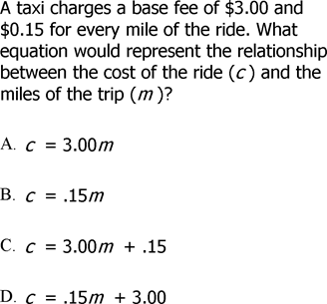
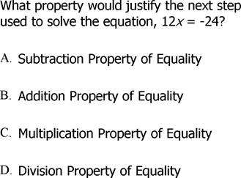
20. 21.

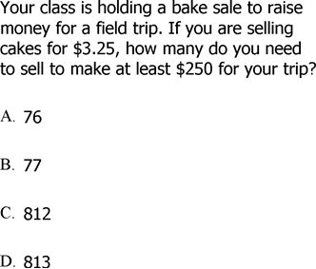
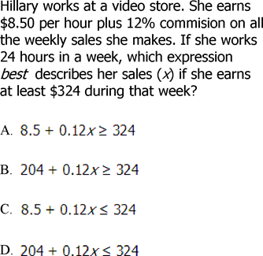
22. 23.

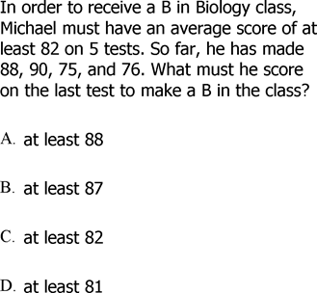
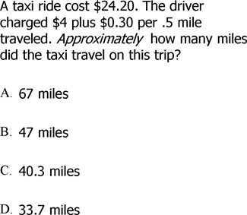
24. 25.

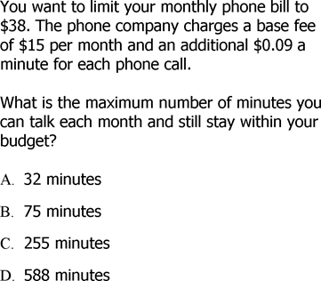
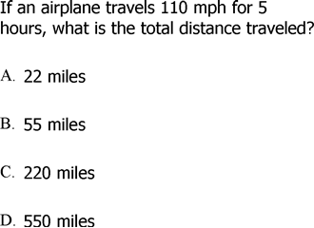
26. 27.

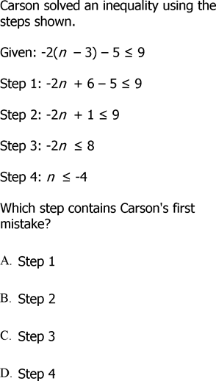
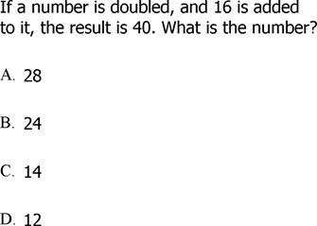
28. 29.

Unit 2- Functions
Find the range of each function when the domain is $\{-4, 0, 1, 5\}$
1. $y=4x-7$ 2. $m=0.5n+3$ 3. $p=q^{2}+1$

Determine whether each relation is a function.
x | y
0 | 1
1 | 2
2 | 3
1 | 4
x | Y
0 | -2
2 | 0
-2 | -4
4 | 2
x | y
2 | -3
-1 | -3
0 | -3
5 | 4
4. 5. 6.

Write a function rule for each table of values.
x | y
0 | 1
1 | 3
2 | 5
-3 | -5
x | f(x)
0 | 0
1 | -4.5
-1 | 4.5
2 | -9
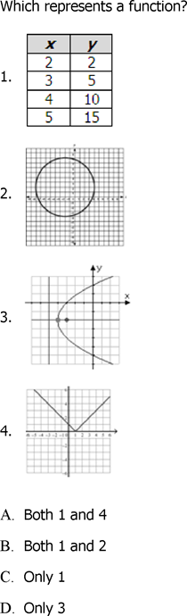
7. 8. 9.

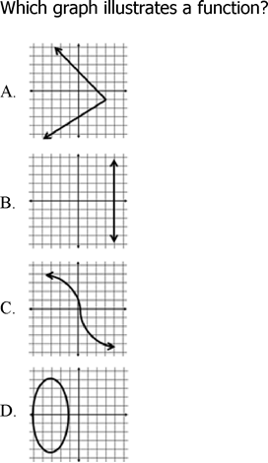
10.

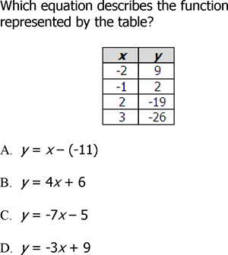
11. 12.

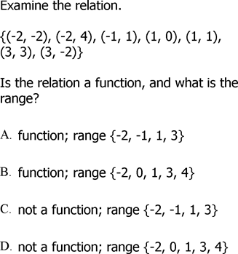
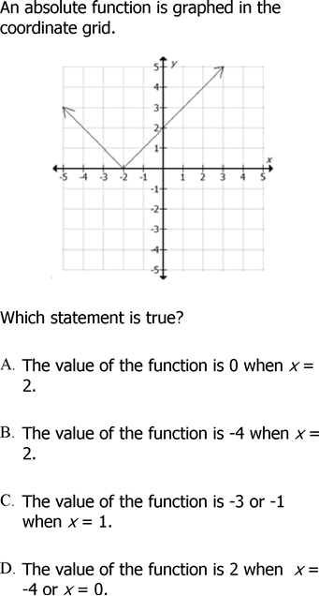
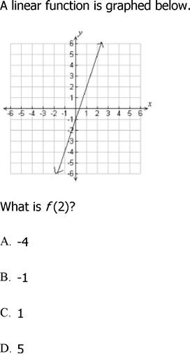
13. 14.

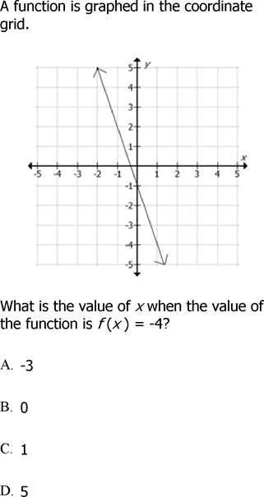
15.
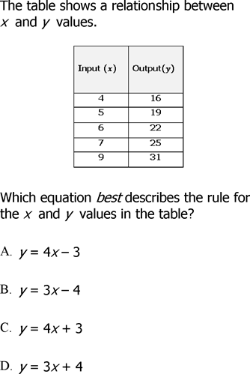
16.

Unit 3- Linear Equations
Find the slope of the line that passes through each pair of points.
1. $(3, -2)$ and $(-5,-4)$ 2. $(4.5,-1)$ and$(4.5, 2.6)$ 3. $(2,5)$ and $(-5,-2)$

4. Find the x- and y- intercept for the equation: $5x+2y=10$

Write an equation of a line that passes through the point $(1,-2)$ with slope m.
5. $m = 2$ 6. $m=3/4$ 7. $m=0$

Write an equation of a line through the given points.
8. $(4,3), (-2,1)$ 9. $(5,-4), (0,2)$ 10. $(-1,0), (-3,-1)$

Write an equation for each of the following conditions.
11. Parallel to $y=4x-2$ through $(2,-1)$

12. Perpendicular to $y=-3x+7 (3,5)$

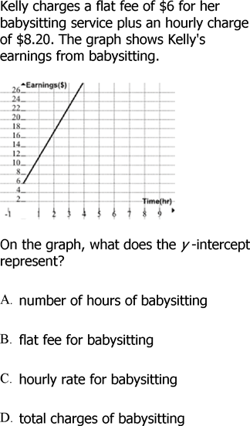
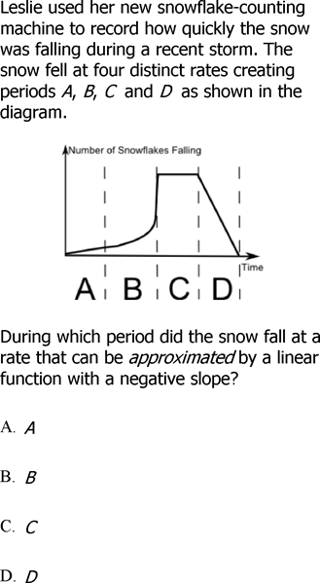
13. 14.

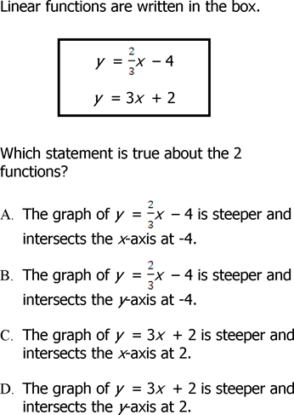
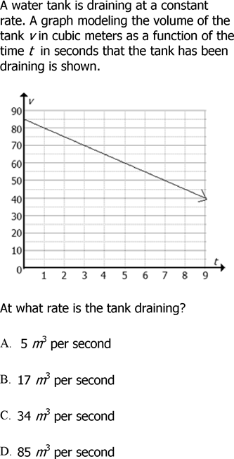

15. 16.

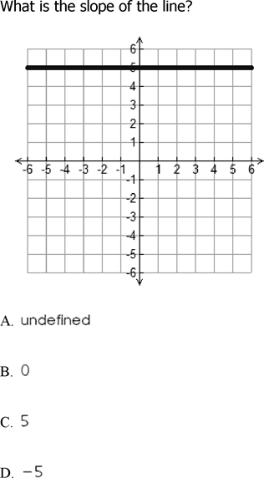
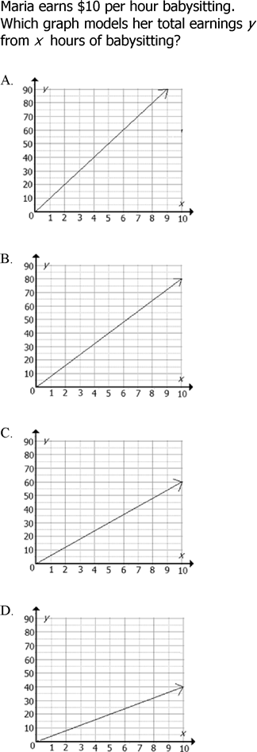
17. 18.

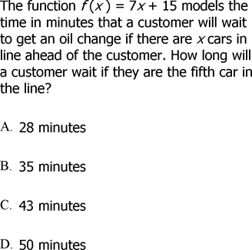
20.

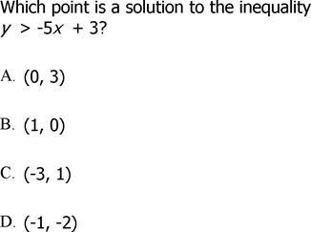
19.

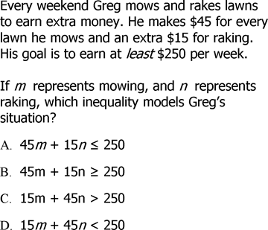
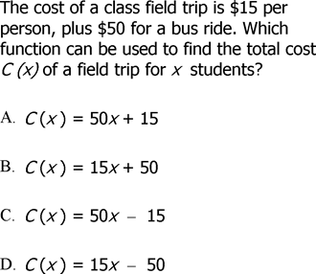
21. 22.

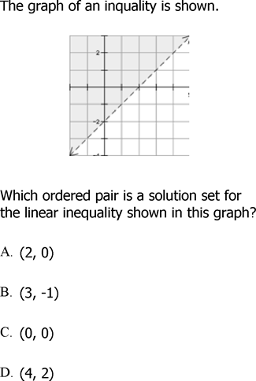
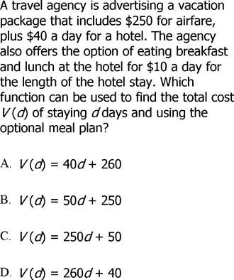
23. 24.

Unit 4- Geometry
State the following:

Pythagorean Theorem ___________________________________

Distance Formula _______________________________________

Midpoint Formula _______________________________________

1. Three vertices of quadrilateral ABCD are $A(-4, 3), B(-1, 5), and D(4, -1)$ as shown below.
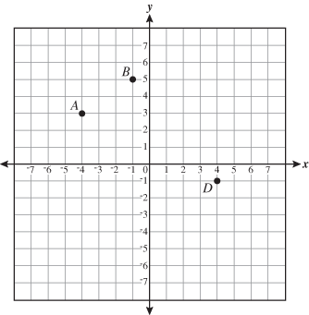
In order for ABCD to be a parallelogram, what must be the coordinates of point C?

Point C: ________________

2. What is the perimeter of the quadrilateral shown in the figure below?
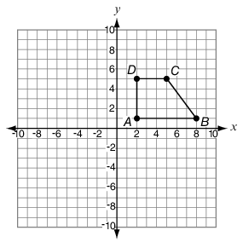

Perimeter = ________________

3. The local planning commission has decided to build a new road from the midpoint of
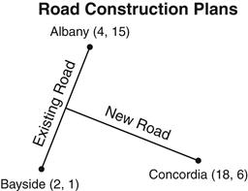
Albany and Bayside to the town of Concordia. If the map coordinates listed on the drawing are in miles, what is the length of the new road, in miles?

Length of the new road = _______________

4. The vertices of a quadrilateral are $M(–1, 1), N(1, –2), O(5, 0), and P(3, 3).$ Which
statement best describes Quadrilateral MNOP?

- Quadrilateral MNOP is a rectangle.
- Quadrilateral MNOP is a trapezoid.
- Quadrilateral MNOP is a rhombus, but not a square.
- Quadrilateral MNOP is a parallelogram, but not a rectangle.

5. The vertices of quadrilateral RSTU are located at $R(–3, 4), S(3, 7), T(5, 3),$
$and U(–1, 0).$ Which best describes quadrilateral RSTU?

A. Square with side length $\sqrt{20}$ B. Square with side length $\sqrt{5}$
C. Rectangle with side lengths $\sqrt{20}$ and $\sqrt{5}$ D. Rectangle with side lengths $\sqrt{20}$ and $\sqrt{45}$

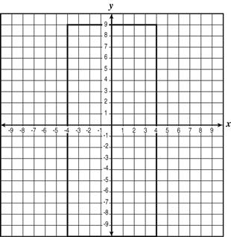
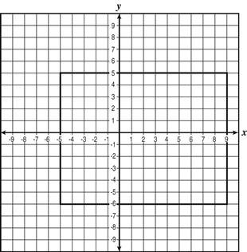
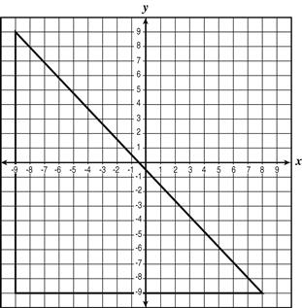
6. Which of the following polygons has the least (smallest) area?
A. B. C.

7. Rectangle QRST has two vertices at Q(–9, 5) and R(–7, 7). If the area of rectangle QRST
is 16 square units, which could be the coordinates of S?
A. (0, 0) B. (–4, 4) C. (–3, 3) D. (–2, 2)

8. The coordinates of the midpoint of a line segment are (9, –13). The coordinates of
an endpoint of the segment are (–4, 5). What are the coordinates of the other endpoint?
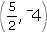
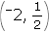
A. B. C. (14, –21) D. (22, –31)

9. A line segment has endpoints at (–3, –5) and (6, 1). In which quadrant does the midpoint
of the segment lie?

A. I B. II C. III D. IV

Unit 5 & 6- Systems of Equations & Inequalities
1. Is (2,5) a solution of the following system?
$$y=2x+1 \\ 2x-y=8$$

$$y=-\frac{1}{2}x+2 \\ 3x+6y=12$$
2. How many solutions does the following system have?

Solve each system by graphing.
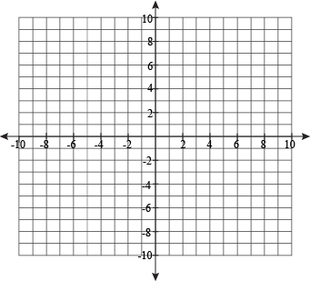
3. $y=3x-1$ 4. $x-y=-3$ 5. $-x+2y=-2 y=-x+3$ $3x+y=-1$ $y=\frac{1}{2}x+3$

Solve each system using substitution.
6. $y=3x+11$ 7. $4x-y=-12$ 8. $y=5x-8 y=-2x+1$ $-6x+5y=-3$ $5y=2x+6$

Solve each system using elimination.
9. $2x-3y=5$ 10. $x+y=10$ 11. $3x+y=5$
$x+2y=-1$ $x-y=2$ $4x+y=-1$

12. There are 24 questions on a test. Each question is worth either 4 points or 5 points. The total is 100 points. How many questions of each type are on the test?

13. A farmer raises chickens and cows. There are 34 animals in all. The farmer counts 110 legs on these animals. How many of each animal does the farmer have?

14. Marcella and Rupert bought some party supplies. Marcella bought 3 packages of balloons and 4 packages of favors for $14.63. Ruper bought 2 packages of balloons and 5 packages of favors for $16.03. Find the price of a package of balloons.

Graph each linear inequality.
15. $y<-3x+8$ 16. $y≥2x-1$

Solve each system of linear inequalities by graphing.
17. $x-y<10$ 18. $y≤x-3$ 19. $y<5x$
$x+y≤8$ $y>x-7$ $y≥0$

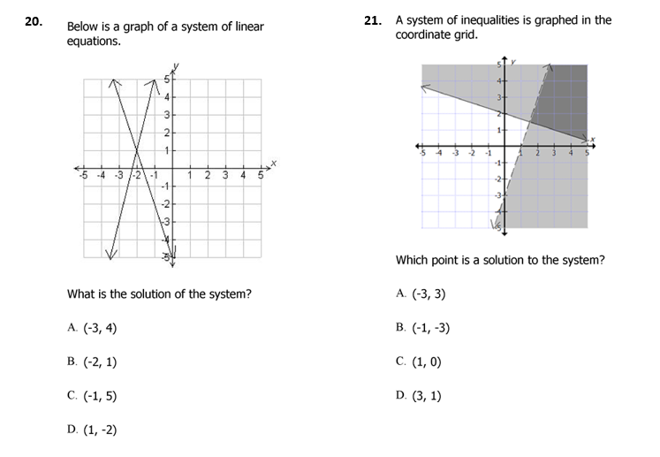

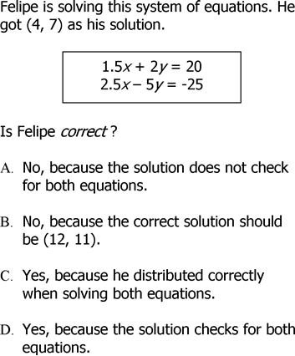
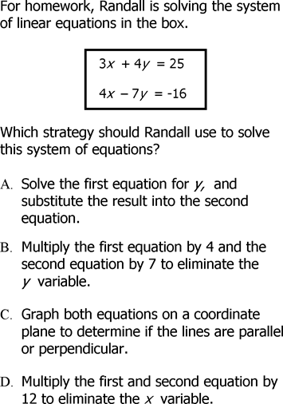
22. 23.

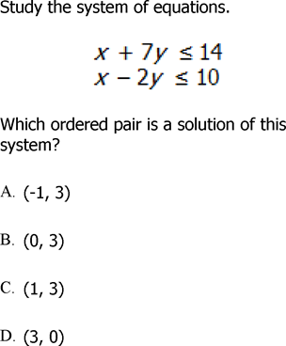
25.
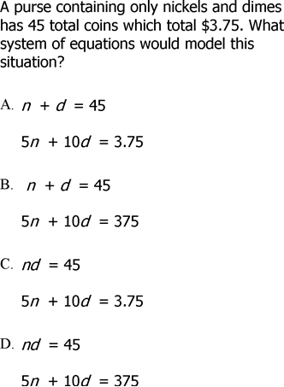
24.

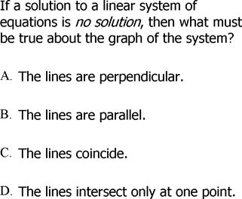
26.

