NCM1B Unit 7B Lesson 1 HWK: Correlations & Scatterplots
Determine whether each scatterplot has a positive, negative, or no correlation.
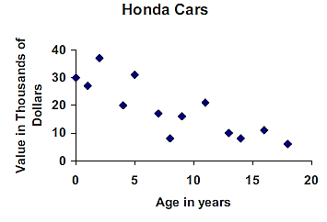
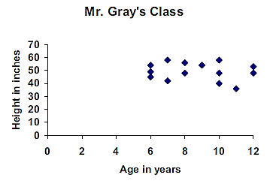
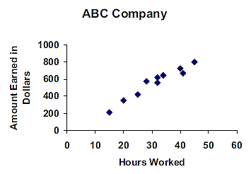
1. 2. 3.

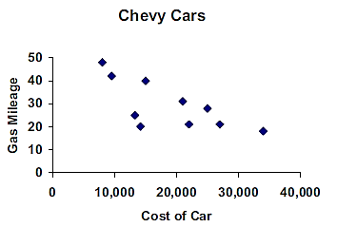
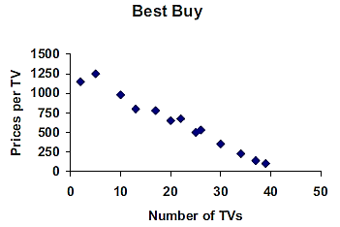
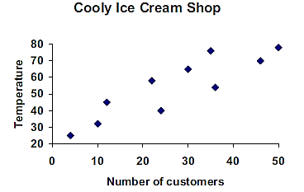
4. 5. 6.

State whether you think the following variables would show a positive, negative¸ or no correlation.
7. Air pollution levels and number of cars on the road
8. Cost of a pair of sneakers and sneakers color
9. Number of calories burned and time exercising
10. How much money you earn and the size of your home
11. Grades in math class and the number of absences from class
Age (years) | Height (inches)
0 | 20.0
2 | 34.5
4 | 41.0
6 | 46.0
8 | 50.5
10 | 54.5
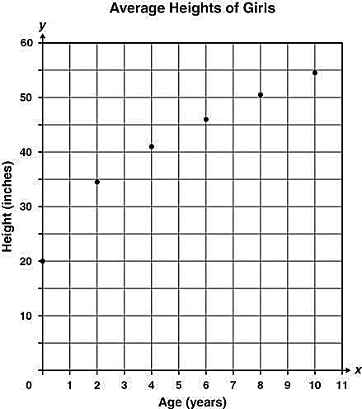
The table and scatterplot on the right shows the average
heights of girls at different ages. The variable x
represents age, in years, and y represents height, in
inches.
12. According to the scatterplot, which equation best
represents the relationship between age and height?
A. $y=0.3x-7$ B. $y=0.4x-12$
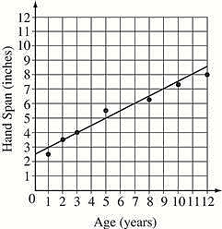
C. $y=2.5x+15$ D. $y=3.2x+25$
The scatterplot on the right shows the hand spans, in inches, of several
children from the ages of 1 through 12.
13. Based on the line of best fit for the data shown on the graph, what is the
predicted age, in years, for a child who has a span of 7 inches?
A. 6 B. 7 C. 9 D. 10

