NC Math I Fall 2016 Math 1B EOC Review
Unit 1-3: Exponents, Polynomials & Factoring

Simplify each expression.

1. $\left(x^{2}y\right)(x^{3}y^{4})$ 2. $\frac{x^{2}}{x^{5}}$ 3. $-{(9x)}^{0}$ 4. ${(3y^{4})}^{3}$

5. $\frac{3x^{2}y^{-3}}{12x^{6}y^{3}}$ 6. ${(2cd^{4})}^{2}{(cd)}^{5}$ 7. ${(\frac{4x^{5}y}{16xy^{4}})}^{3}$

Add or subtract.

8. ($5p^{2}-3)+({2p}^{2}-3p^{3})$ 9. $\left(-9v^{2}-8u\right)+\left(-2uv-2u^{2}+v^{2}\right)-(-{ v}^{2}+4uv)$

10. $\left(-7x^{5}+14-2x\right)+(10x^{4}+7x+5x^{5})$ 11. $\left(4n-3n^{3}\right)-(3n^{3}+4n)$

Find the product.

12. $-3x(x^{2}-7x+1)$ 13. $-2x^{3}\left(3x^{2}+4x\right)+9x^{3}(x^{2}+x+1)$

14. $(x+6)(x-8)$ 15. ${(4x+2y)}^{2}$ 16. $(3x-5)(3x+5)$

17. $(5x-3)(2x-1)$ 18. $(x+5)(5x+2)$

Factor Completely.

19. $12a^{2}b^{2}-3ab$ 20. ${2x}^{5}-8x^{3}$ 21.$x^{2}+5x+6$

22. $6a^{2}-11a+4$ 23. $xy+8x+3y+24$ 24. $3x^{4}-18x^{3}+27x^{2}$

25. $4x^{2}-9$

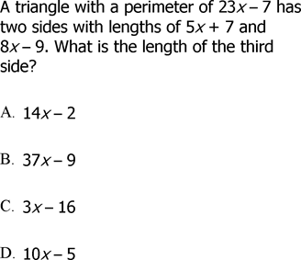
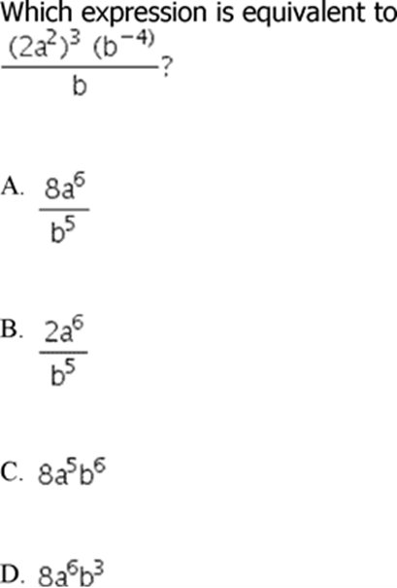
26. 27.

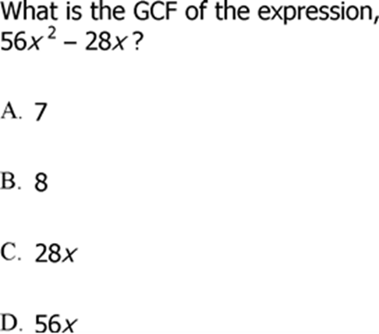
29.

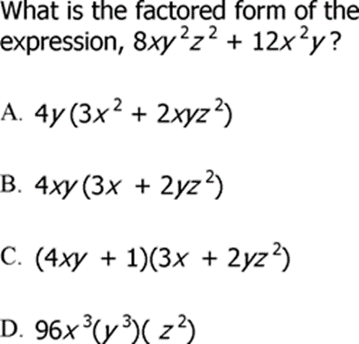
28.

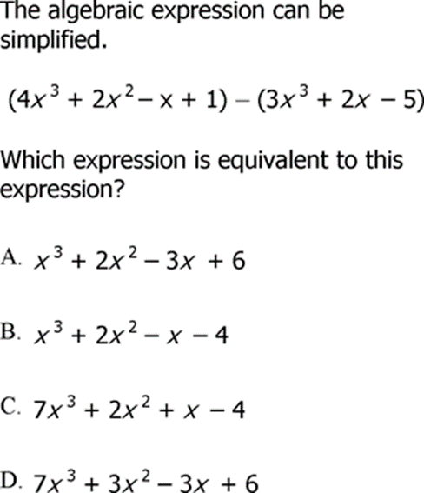
31.

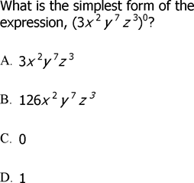
30.

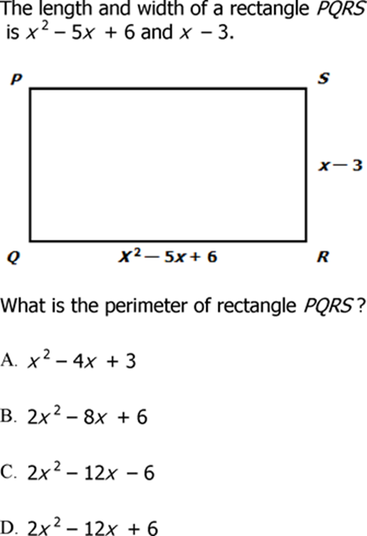
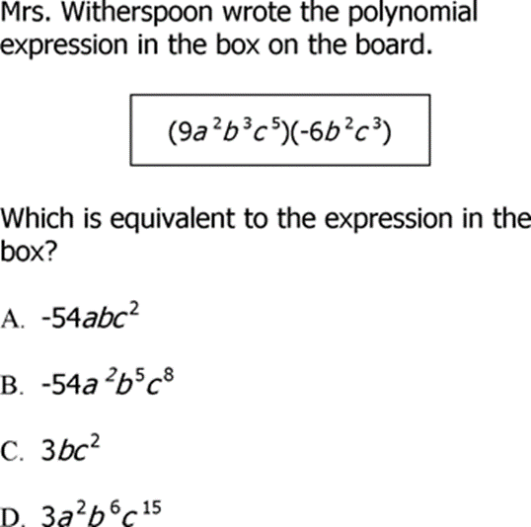
32. 33.

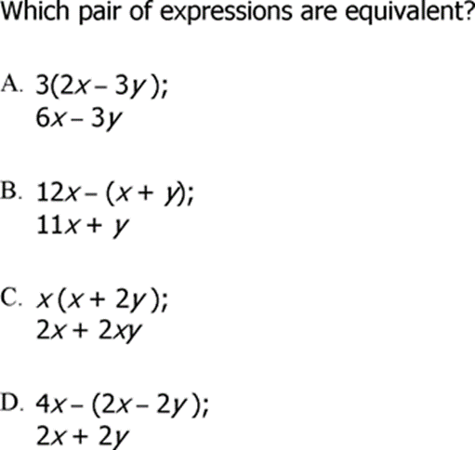
34.

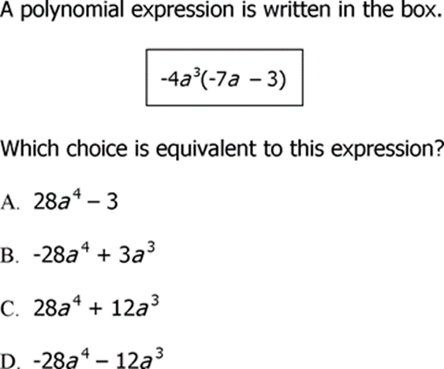
35.

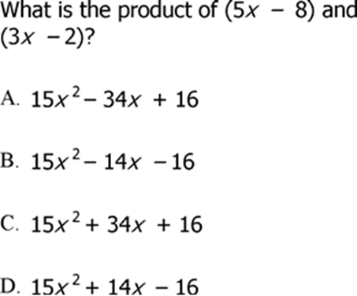
36.

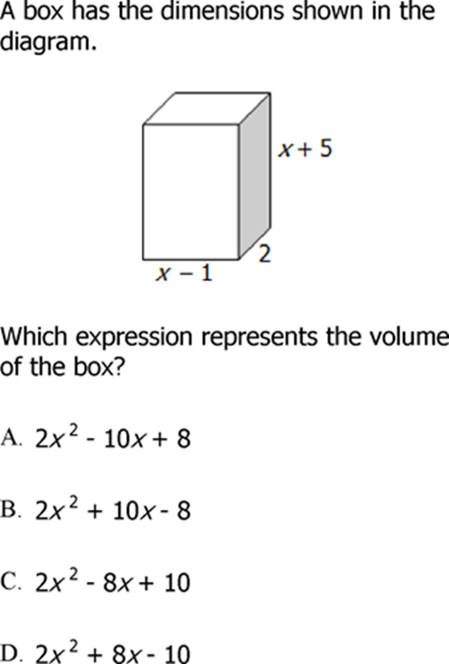
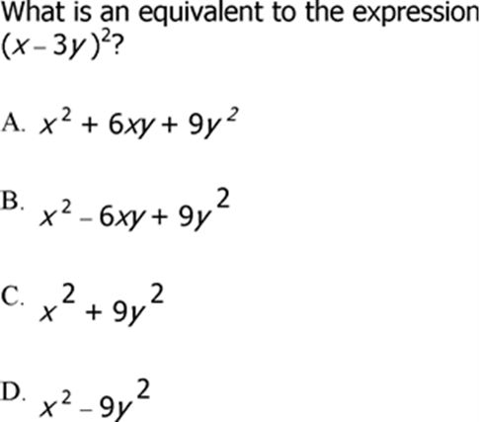
37. 38.

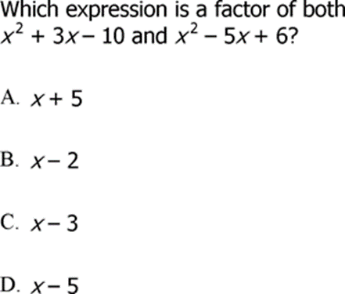
39.

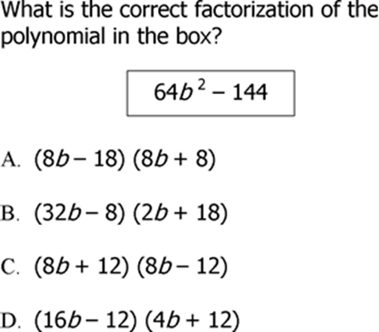
41.

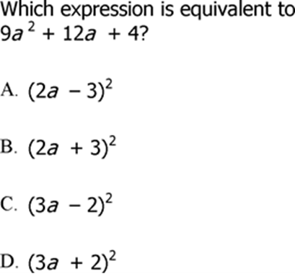
40.

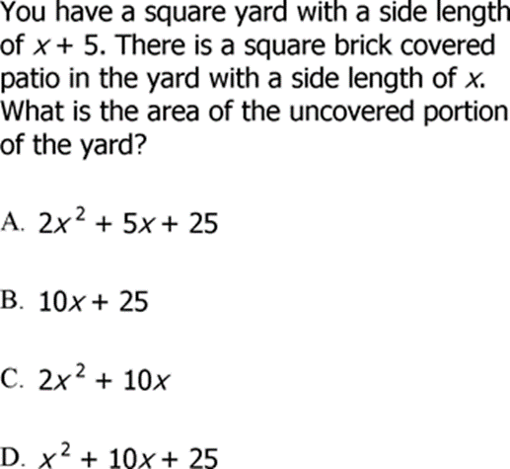
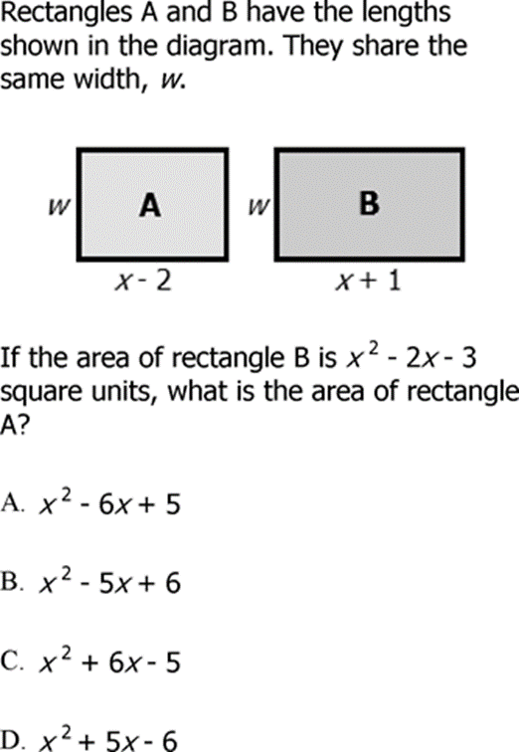
42. 43.

Unit 4- Quadratic Functions

Steps to Solve a Quadratic Function by Factoring

a. _________________________________

b. _____________________________________

c. _____________________________________

d. _____________________________________

Solve each quadratic equation by factoring.

1. $\left(x-6\right)\left(x-3\right)=0$ 2. $x^{2}+5x+4=0$

3. $n^{2}-64=0$ 4. $x^{2}=11x-28$

5. $k^{2}+15k=-56$ 6. $m^{2}=2m$

7. $x^{2}+17x+49=3x$ 8. ${10x}^{2}-26x=-12$

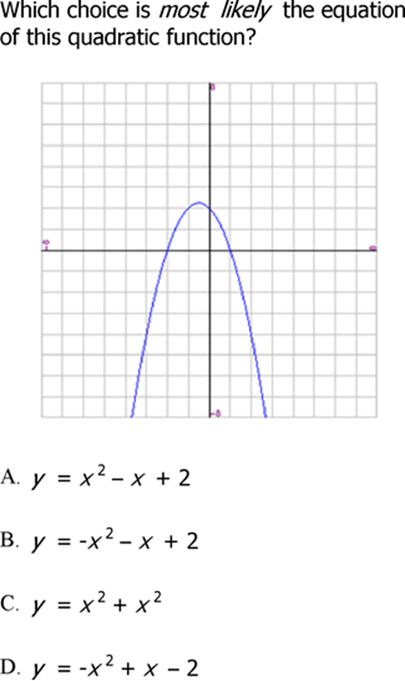
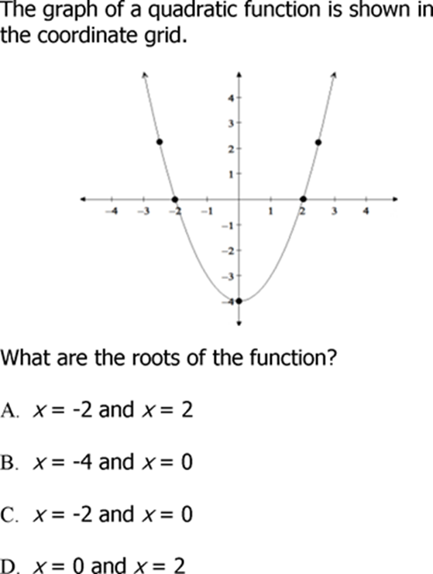
9. 10.
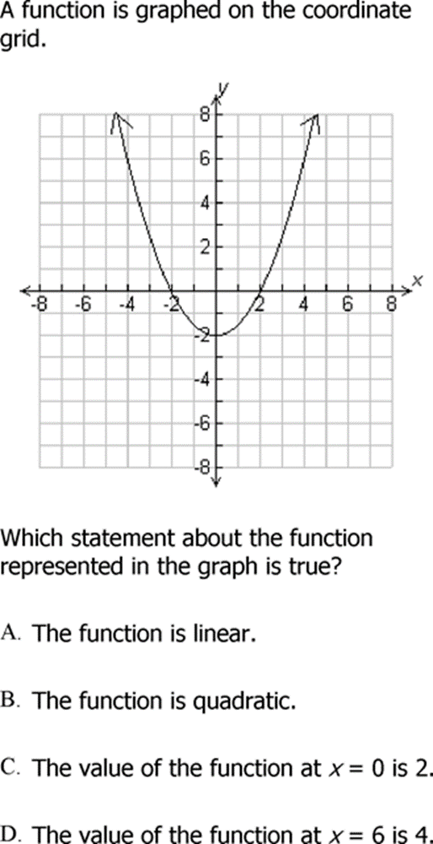
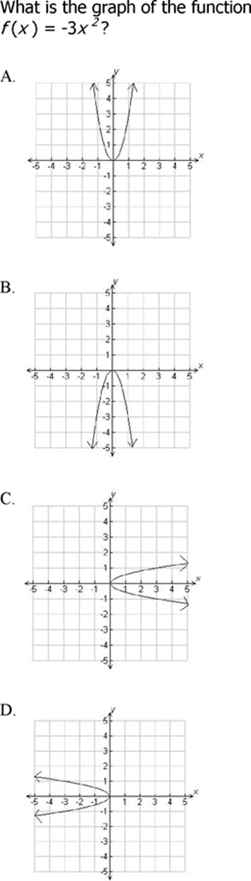
11. 12.

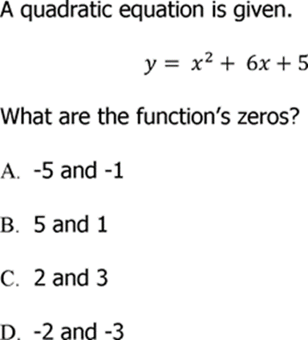
13.

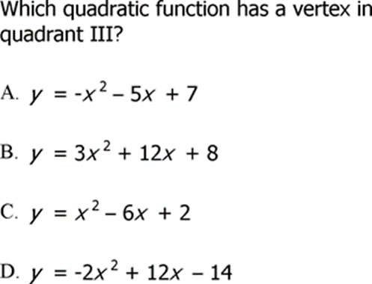
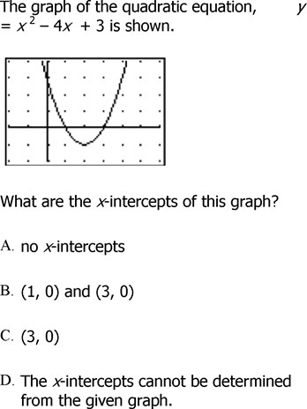
14. 15.

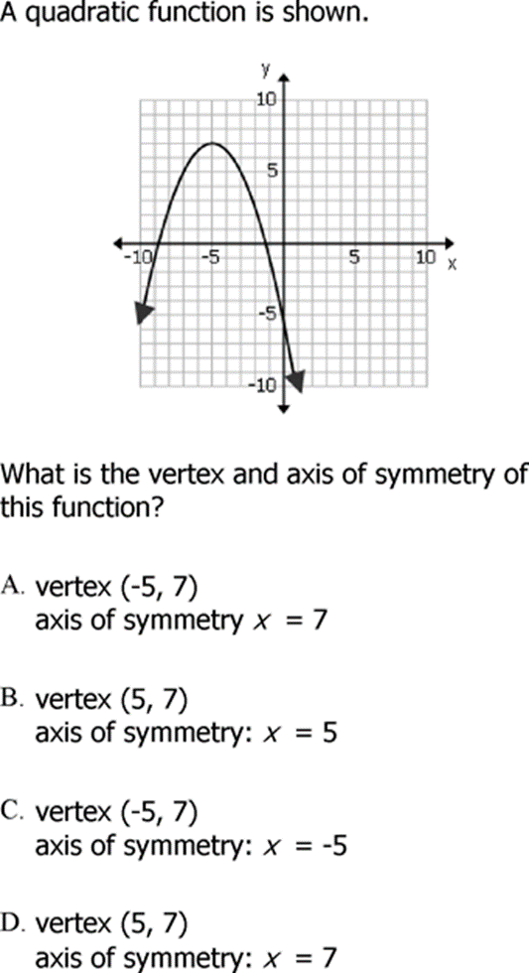
16.

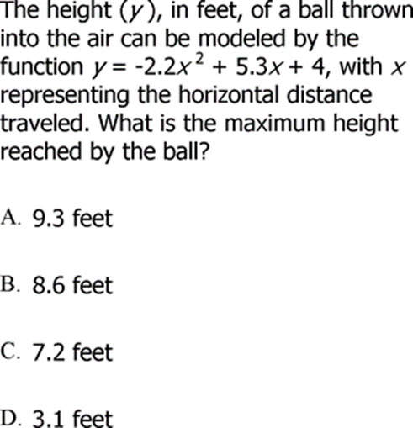
17.

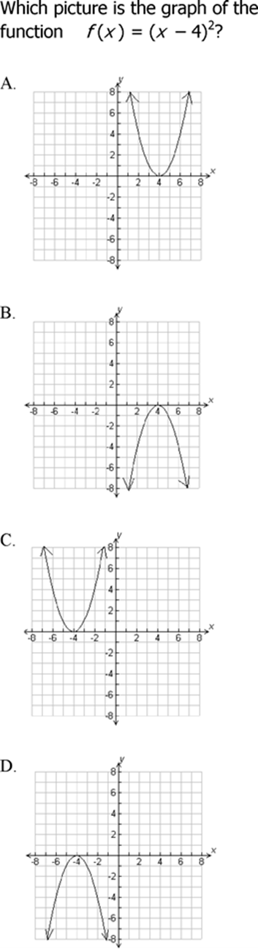
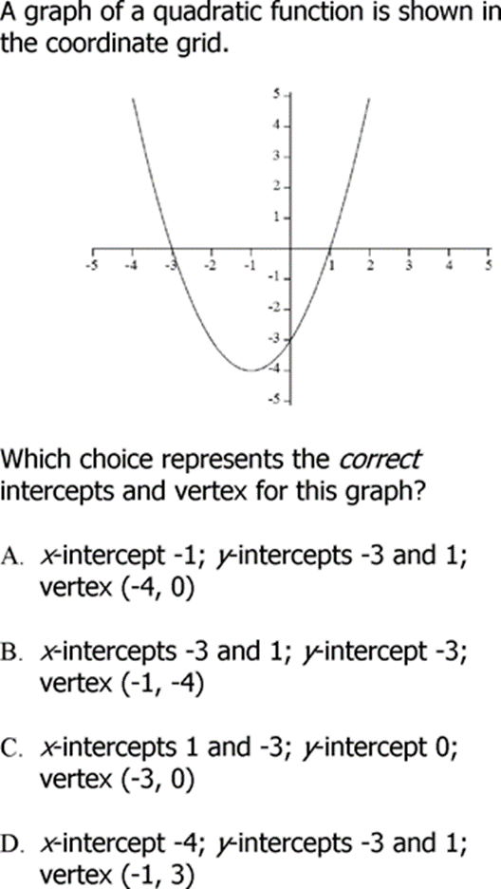
18. 19.

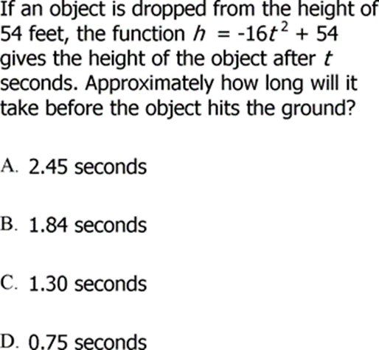
20.

Unit 5- Exponential Functions

Explicit Equation for an Exponential Function: __________________________

a = ______________________ b = ______________________

Explicit Equation for Percent Growth: _______________________________________

Explicit Equation for Percent Decay: _______________________________________

*Remember, there could be a time interval (n), in which the exponent is a fraction: $\frac{x}{n}$.

Formula for Compounded Interest: _____________________________________

a = ______________________ r = ______________________

n = ______________________ x = ______________________

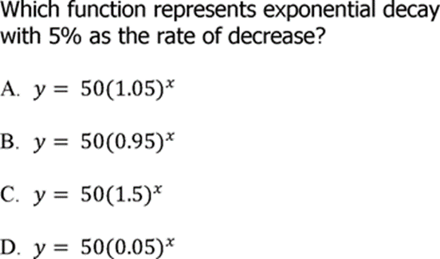
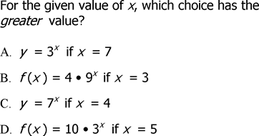
1. 2.

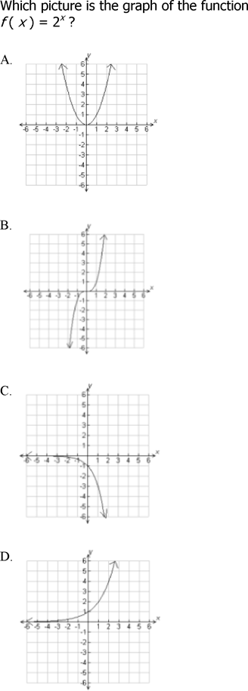
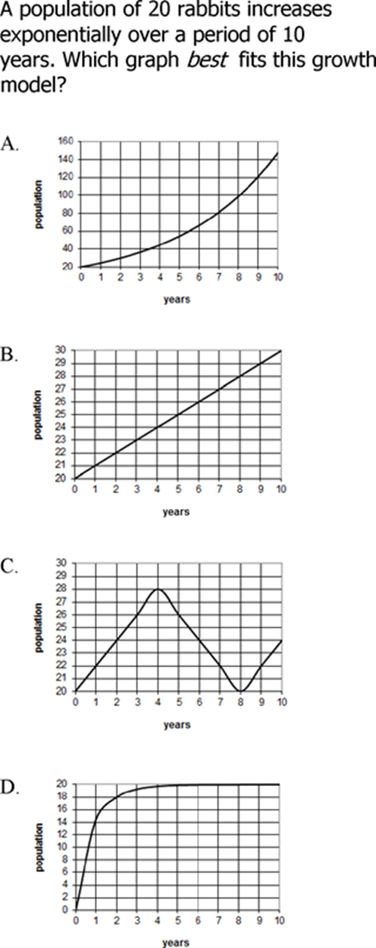
3. 4. 4.

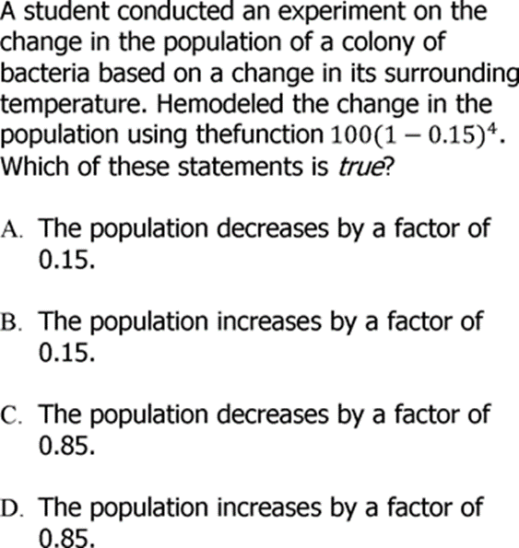
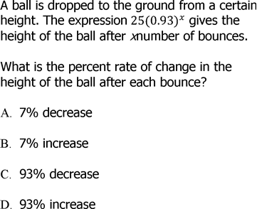
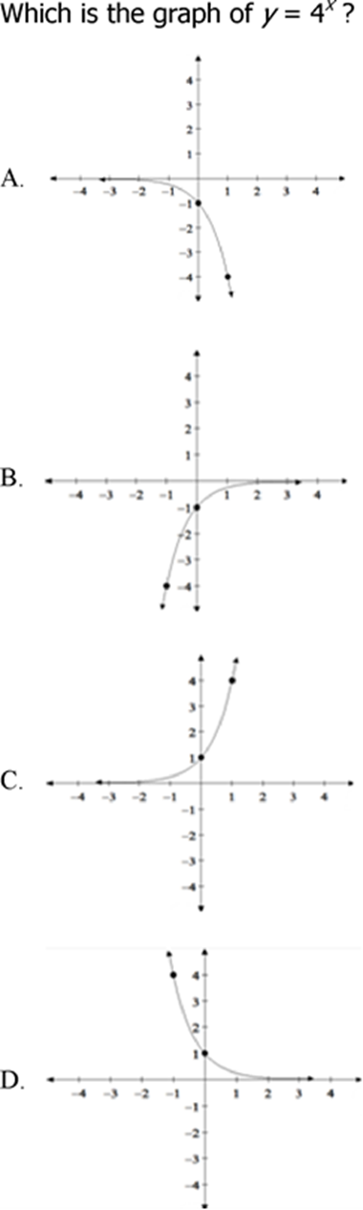
5. 6.
7.
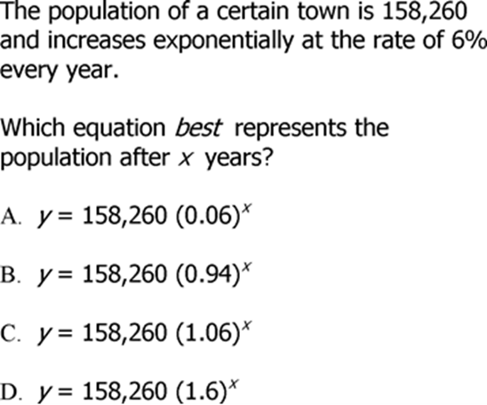
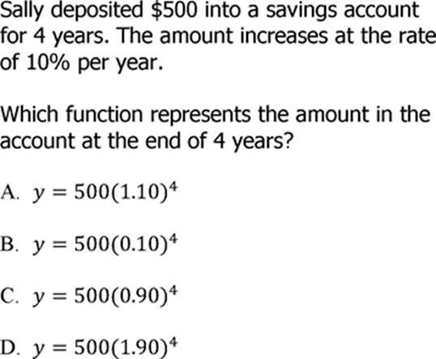
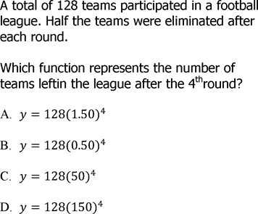
8. 9.
10.

